



**CSCI321 – Project**

**USER MANUAL**

**FOR**

**FYP-23-S1-14**

## 

**Project Team**

| Group: FYP-23-S1-14 | | |
| --- | --- | --- |
| Student ID: | Name: | Email: |
| 7222828 | Loo Joon Wee | [jwloo002@mymail.sim.edu.sg](mailto:jwloo002@mymail.sim.edu.sg) |
| 7372772 | Low Rui Hao | [rhlrlow001@mymail.sim.edu.sg](mailto:rhlrlow001@mymail.sim.edu.sg) |
| 7436208 | Muhamad Amir Akmal BMS | [mohammad103@mymail.sim.edu.sg](mailto:mohammad103@mymail.sim.edu.sg) |
| 7224527 | Tham Jia Xuan Travis | [jxttham001@mymail.sim.edu.sg](mailto:jxttham001@mymail.sim.edu.sg) |
| 7222439 | Wee Zee En Leonard | [zelwee001@mymail.sim.edu.sg](mailto:zelwee001@mymail.sim.edu.sg) |
| Supervisor: | Mr Terence Chew | [tchew@uow.edu.au](mailto:tchew@uow.edu.au) |
| Accessor: | Dr Prem | [premrajan_p@yahoo.com](mailto:premrajan_p@yahoo.com) |

## 

| **Document Control** | | | | | | | | |
| --- | --- | --- | --- | --- | --- | --- | --- | --- |
| **Title:** | | **User Manual** | | | | | | |
| **Document Name:** | | **User Manual, Version #6** | | | | | | |
|  | | | | | | | | |
| **Record of Revision** | | |  | |  | |  | |
| **Revision Date** | **Description** | | | **Section Affected** | | **Changes Made by** | | **Version after Revision** |
| **17 May** | **User Manual** | | | **Workflow 2** | | **Leonard Wee** | | **1** |
| **18 May** | **Tech installation** | | | **Workflow 1** | | **Leonard Wee** | | **2** |
| **19 May** | **Tech installation & User Manual** | | | **Workflow 1 & 2** | | **Leonard Wee** | | **3** |
| **20 May** | **Tech installation & User Manual** | | | **Workflow 1 & 2** | | **Leonard Wee** | | **4** |
| **24 May** | **Tech installation & User Manual** | | | **Workflow 1 & 2** | | **Leonard Wee** | | **5** |
| **28 May** | **Tech installation & User Manual** | | | **Workflow 1 & 2** | | **Leonard Wee** | | **6** |

Table of Contents

**Document Control 3**

**1. Introduction 5**

**2. Scope and Purpose 5**

**3. Process Overview 6**

**4. Workflow 7**

4.1. Workflow 1 7

4.1.1. Sign up to AWS Free Tier: 7

4.1.2. Remote Desktop: 22

4.2. Workflow 2 61

4.2.1. Account creation – Sign up via email: 61

4.2.2. Log In: 68

4.2.3. Tabs in workspace: 70

4.2.4. Account settings: 88

4.2.5. User Profile: 92

4.2.6. Log Out: 94

4.2.7. Admin User: 96

# **Introduction**

The prerequisite requires a debit/credit card that is needed to set up an AWS account, however this is for Amazon verification purposes. The signup process for AWS account will not be shown as it is filling in personal details and the user’s debit/credit card.

# Scope and Purpose

To design and develop a product to provide service to our clients in knowing their specific target audience preferences and ratings on different items as well as providing the client's recommendations on products that the specific target audience might be interested in, so that they can better provide their services and products to their customers. Individual customers can also use our service to check on relatable or similar products based on the product they enter in our service, and we will web crawl it on other websites and provide the answer to the individuals. The crawling component will be through websites like Lazada, Amazon, Shopee, Alibaba.

# Process Overview

Workflow 1:

* Sign up to AWS Free tier
* Setting up the instance through a remote desktop.

Workflow 2:

* Account creation - Sign up
* Log In
* Tabs in workspace
  1. Organization
     1. Discover tab
     2. Instructions tab
     3. Your Data
  2. Individual
     1. Discover tab
     2. Instructions tab
  3. Individual/Organization tabs
  4. Upgrade Plan
  5. Quota and billing Page
     1. Individual
     2. Organization
* Account settings
* User Profile
* Log Out
* Admin User
  1. Search Account
  2. Manage Account
     1. Edit
     2. Manage
     3. Delete
  3. Create Account
     1. Organization
     2. Individual
     3. Admin User

# **Workflow**

## Workflow 1

### Sign up to AWS Free Tier:

Head to this website and click on create a free account:

[https://aws.amazon.com/free/?all-free-tier.sort-by=item.additionalFields.SortRank&all-free-tier.sort-order=asc&awsf.Free%20Tier%20Types=*all&awsf.Free%20Tier%20Categories=*all](https://aws.amazon.com/free/?all-free-tier.sort-by=item.additionalFields.SortRank&all-free-tier.sort-order=asc&awsf.Free%20Tier%20Types=*all&awsf.Free%20Tier%20Categories=*all)

Go through the sign up process and you will get this page after registration success:

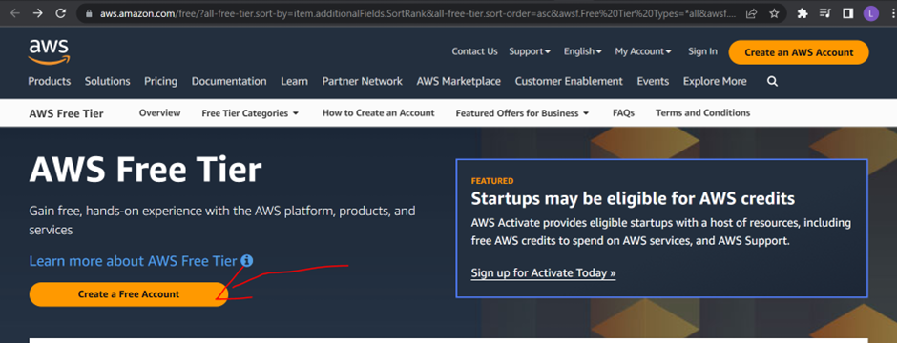

Go through the signup process and you will get this page after registration success:

Click on the Go to the AWS management Console to log in.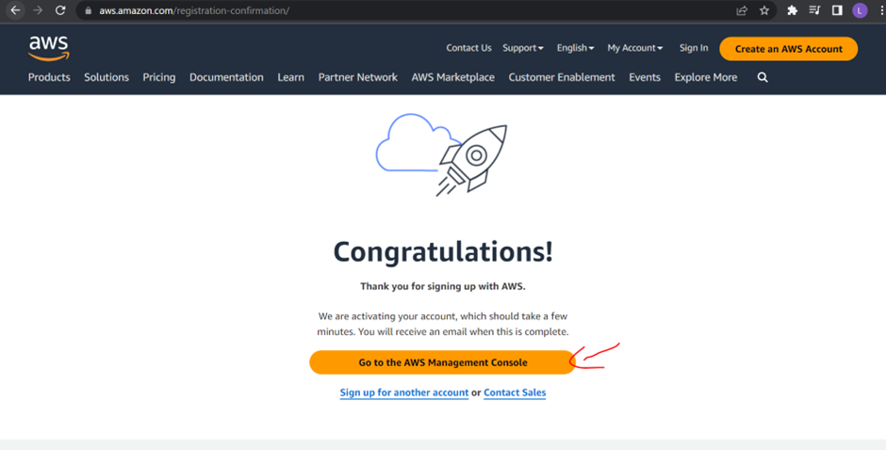

Sign in via Root user: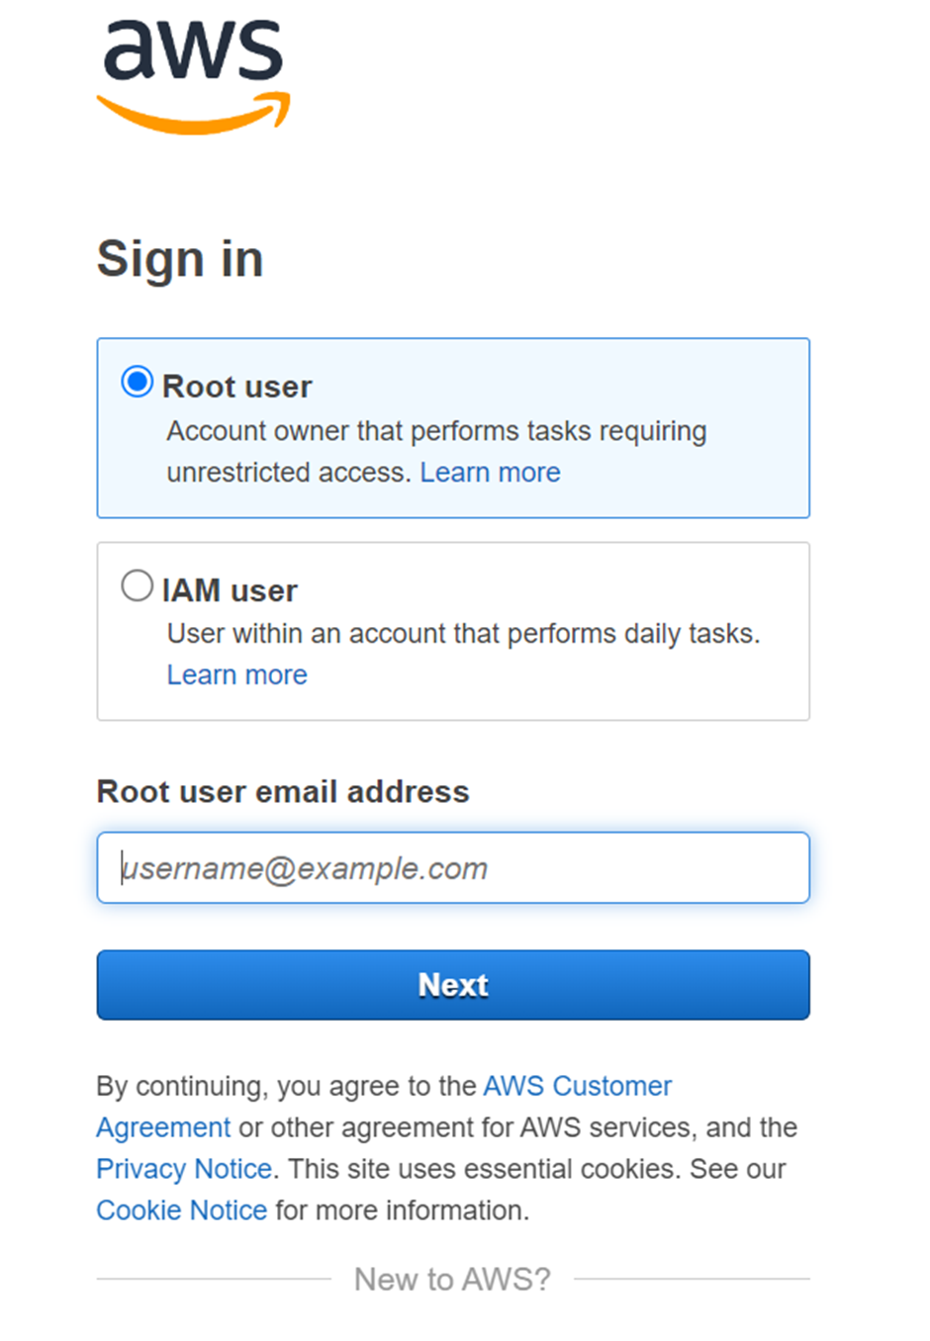

Search for EC2 and click on it:

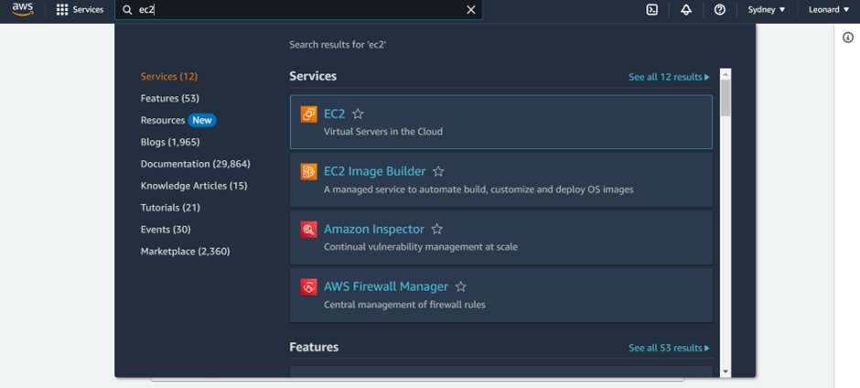

Click on Instance then Launch instance:

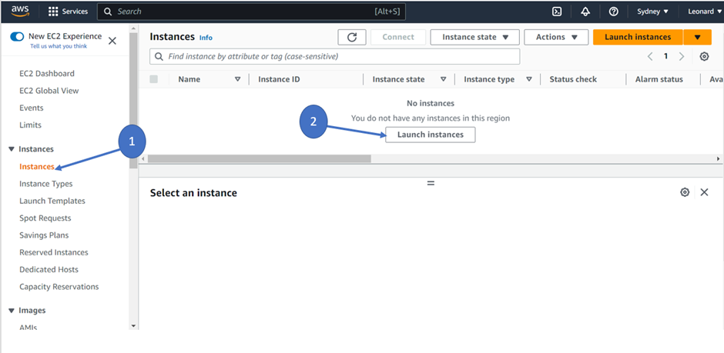

Click onto windows:

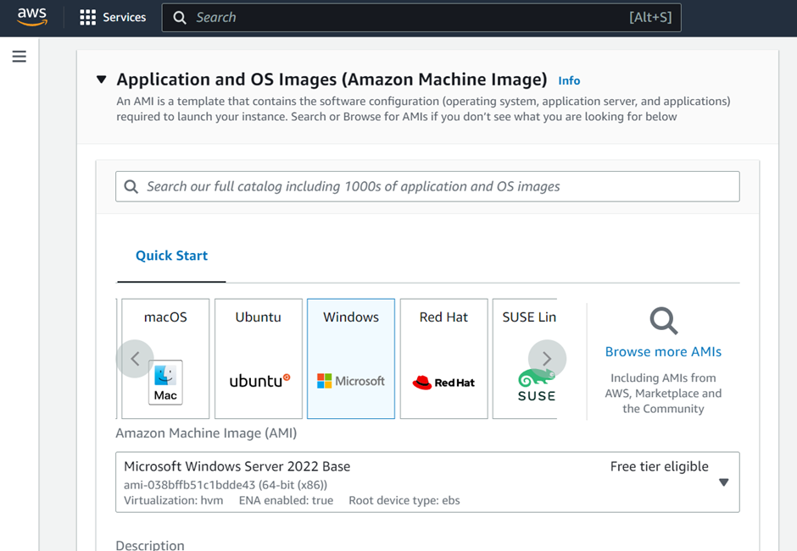

Click on create new key pair:

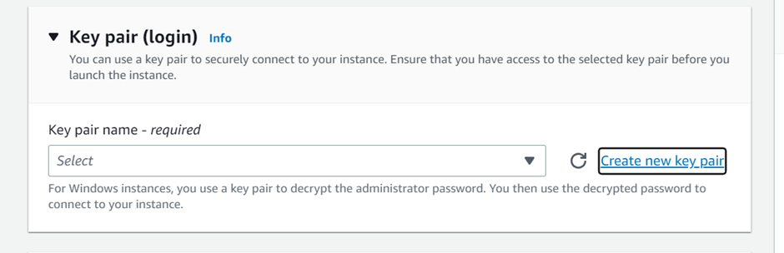

Type in fyprecs in the blank and click create key pair:

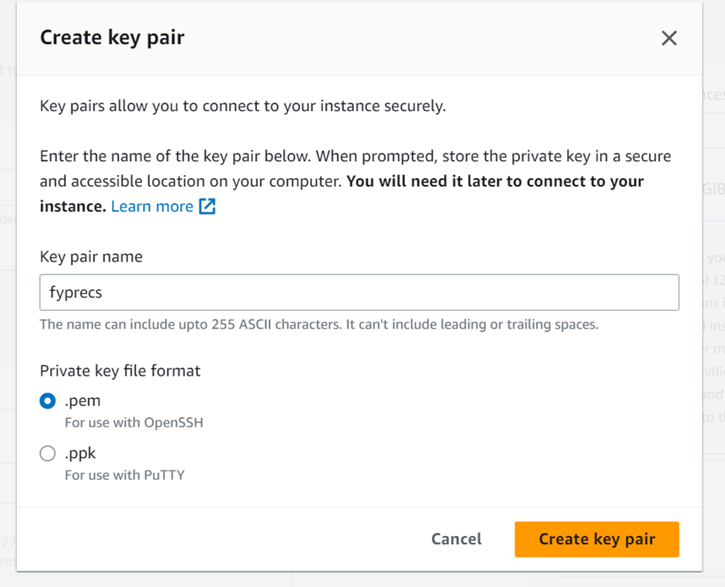

Save the file in your local drive for use later.

Select Edit on Network settings:



Select first subnet under Network tab:

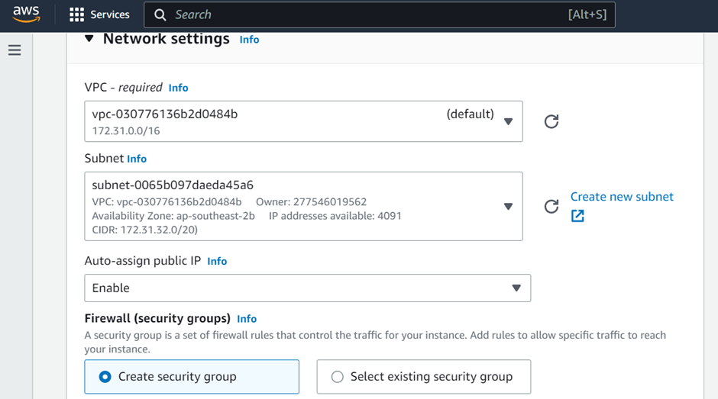

Change Security group name to FYPRECs-web-sg:

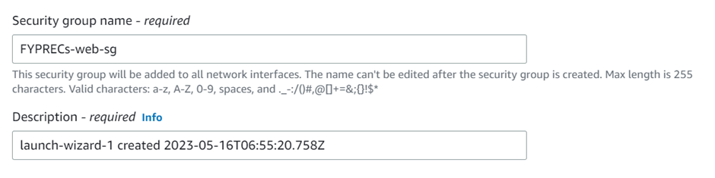Click on “add security group rule”:

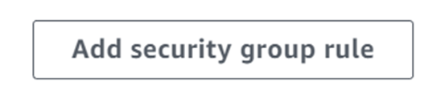Change Type under dropdown list to select HTTP and select Source type to Anywhere:

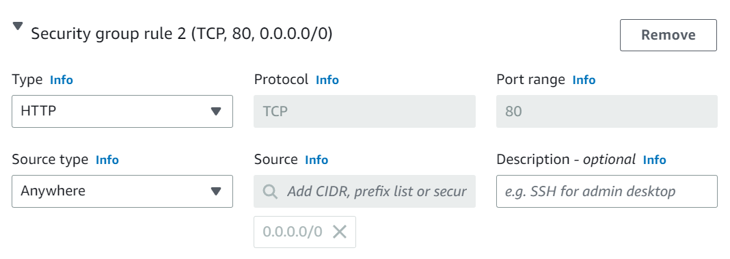

Click Launch instance:

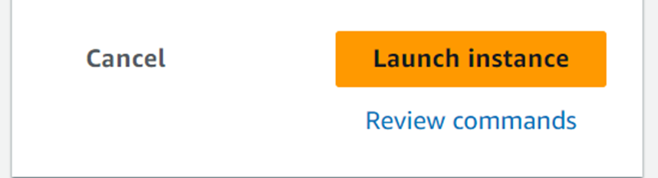

Wait for 3 to 5 minutes for the Status check to turn to 2/2 checks passed:

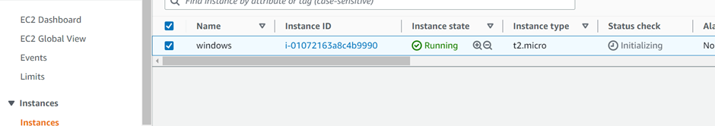

Refresh the webpage to see the status check turn to 2/2 checks passed:

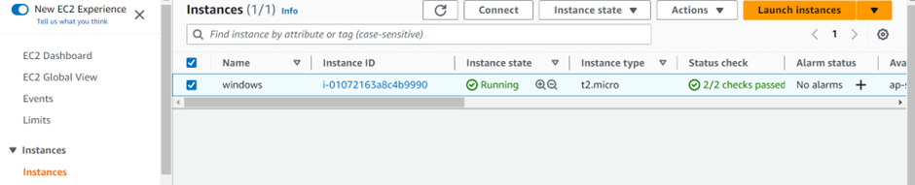

Tick the checkbox on the windows, click Actions, Security, then Get Windows password:

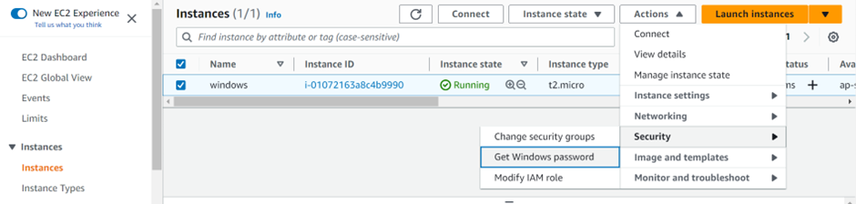

Upload the private key that was saved previously in your local drive to get your password:

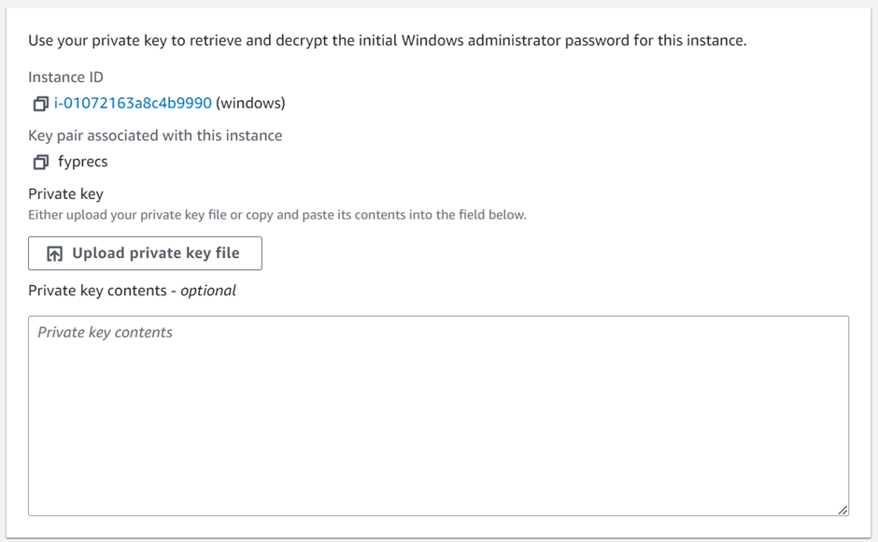

Click decrypt password:

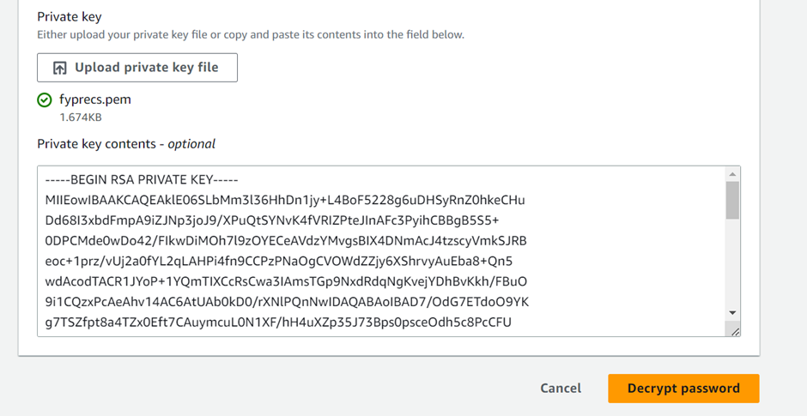

Copy Paste the private IP address and Password and save it onto a .txt file:

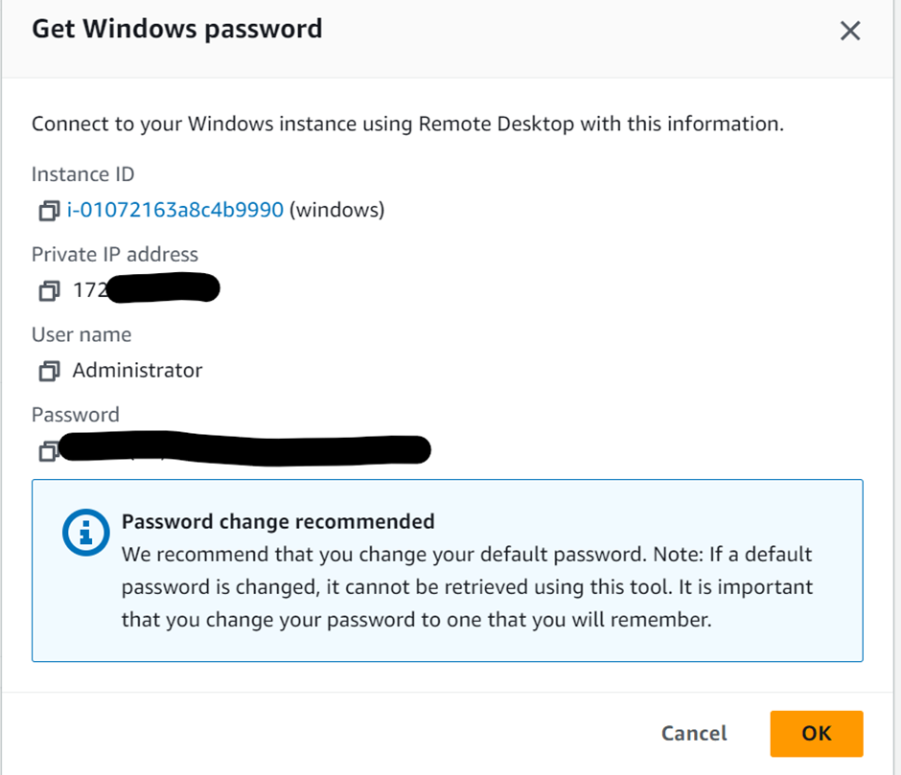

Click the checkbox on the name, and click Connect. Note: These steps of downloading the rdp file will required to be done again if you do stop the instance, and start it back up:

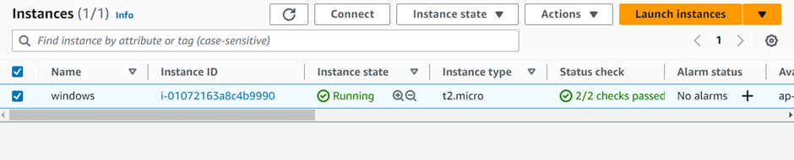

Click RDP client

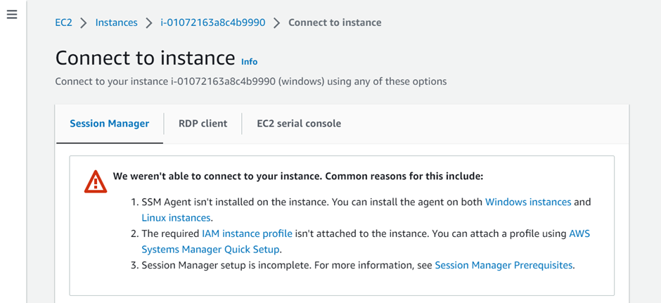

Scroll down and click Download remote desktop file:

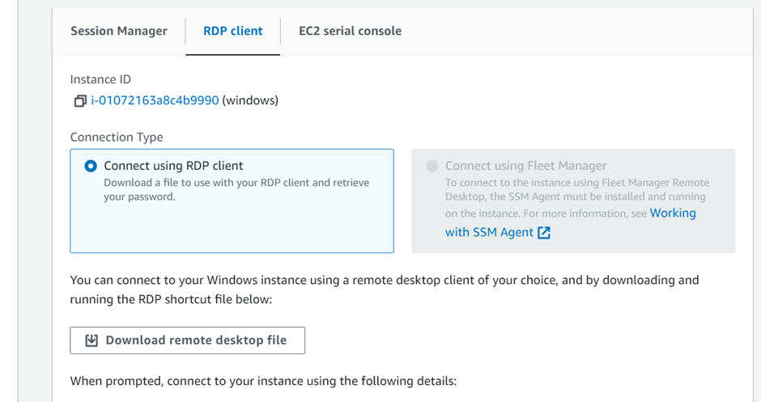

Open the fyprec.rdp file where you saved the file:



Click Connect:

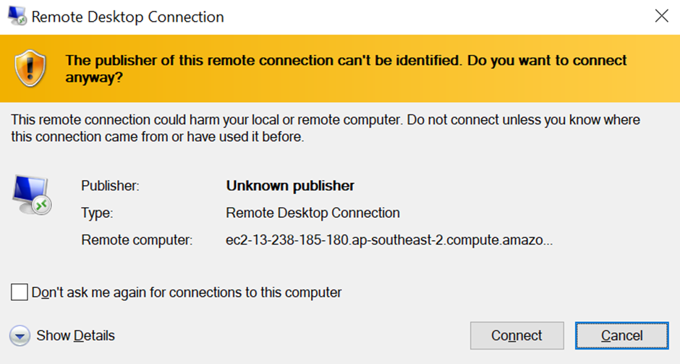

Copy and paste the password that was saved in the txt file previously to log into remote desktop, click ok:

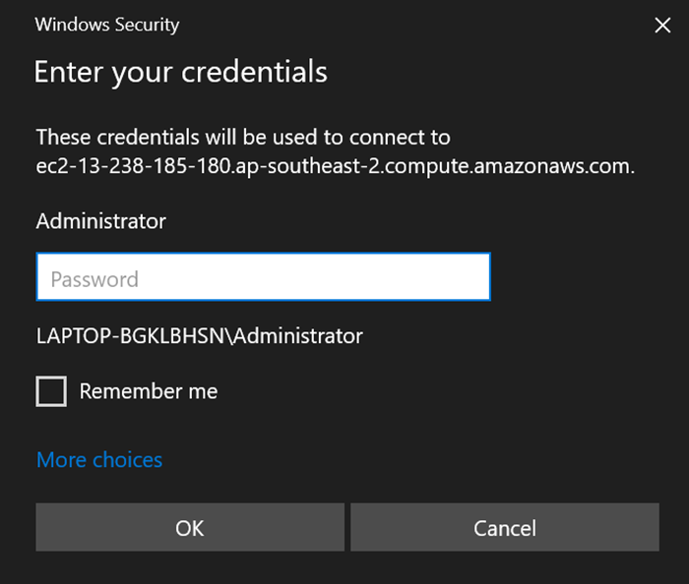

Click Yes:

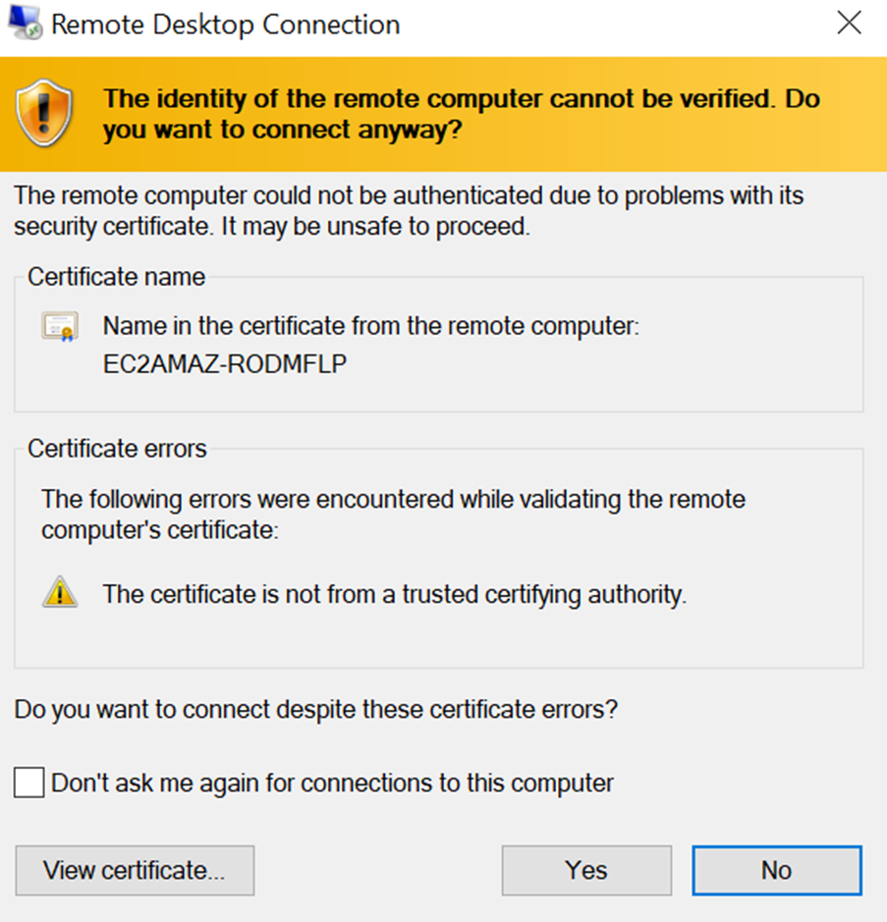

### 

### Remote Desktop:

Search for Windows Defender Firewall with Advanced Security, open it:



Click windows defender properties:

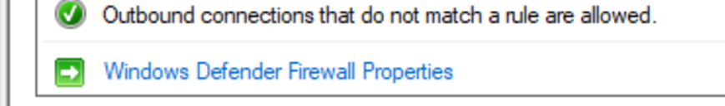

Click on public profile, allow for Inbound connections:

Click apply and Ok

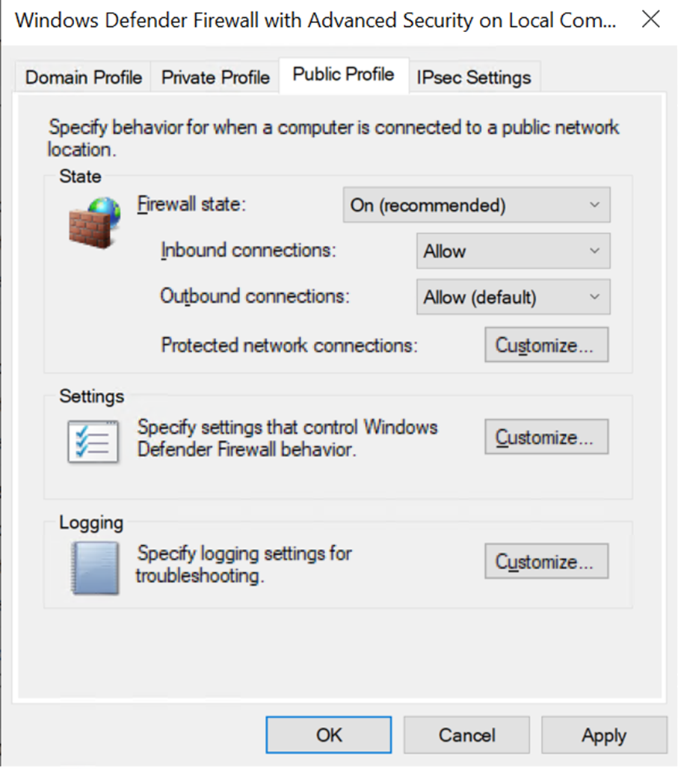

Download xampp 8.2.4 version:

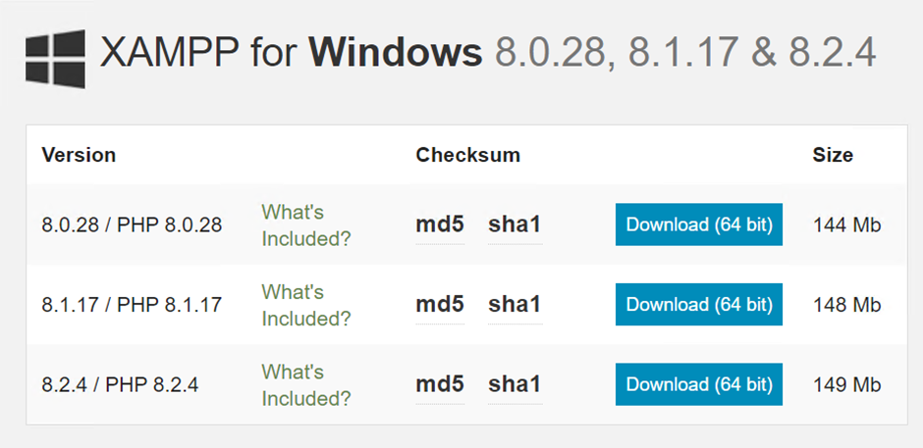

Click Next until the installation is done:

Click Finish and it will start the xampp control panel:

Click both Start for Apache and MySQL:

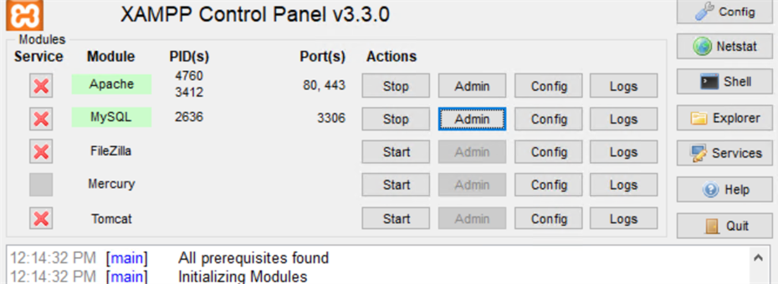

Type your public IP address into edge, if you see this, the install is done:

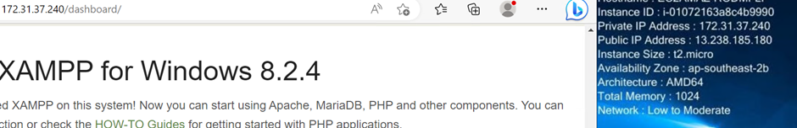

If you face any issues with Apache port selection:

Search for command prompt and run net stop was /y:

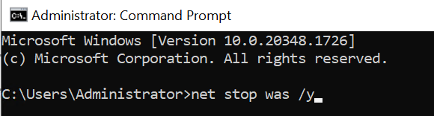

Install Python 3.11.3 by going to https://www.python.org/downloads/

Open the installer, and check Add python.exe to Path, and click Install now :

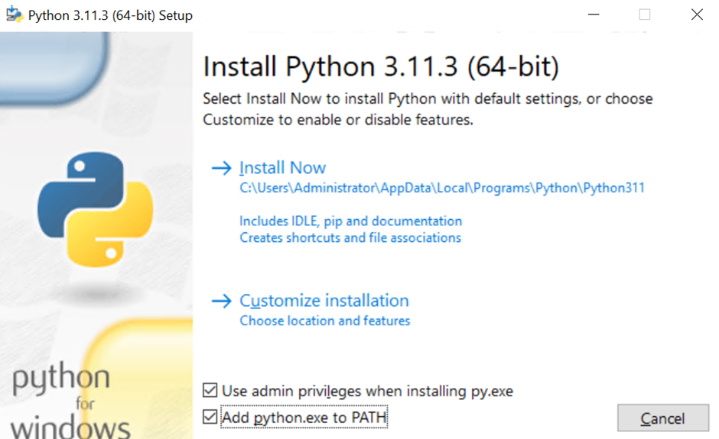

Click finish after it is done.

Find “env” in search and click Edit the system environment variables:

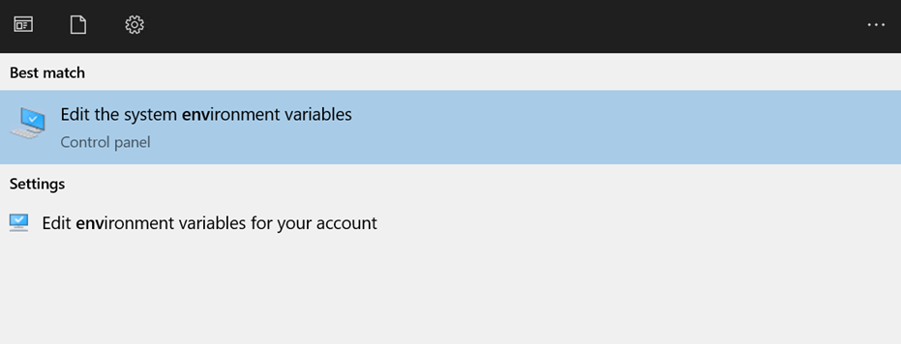

Click Environment Variables:

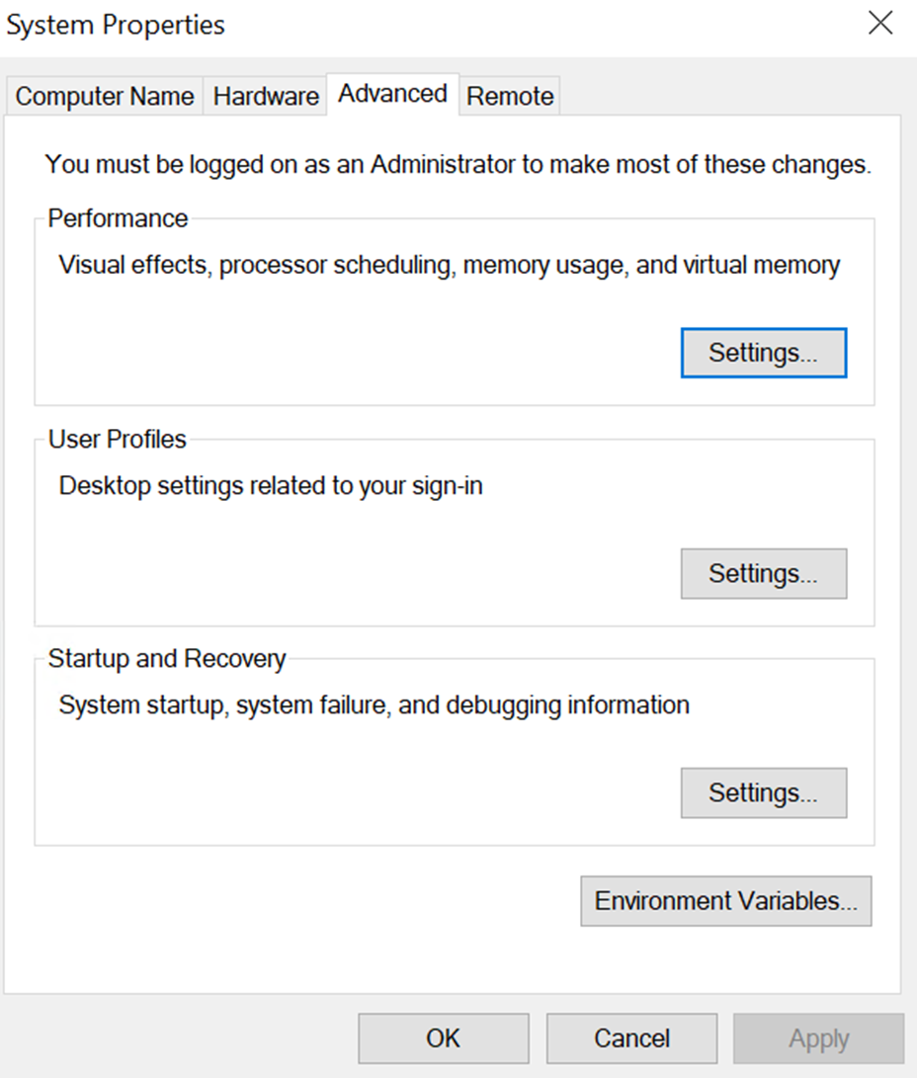

Double click Path under User variables for Administrator:

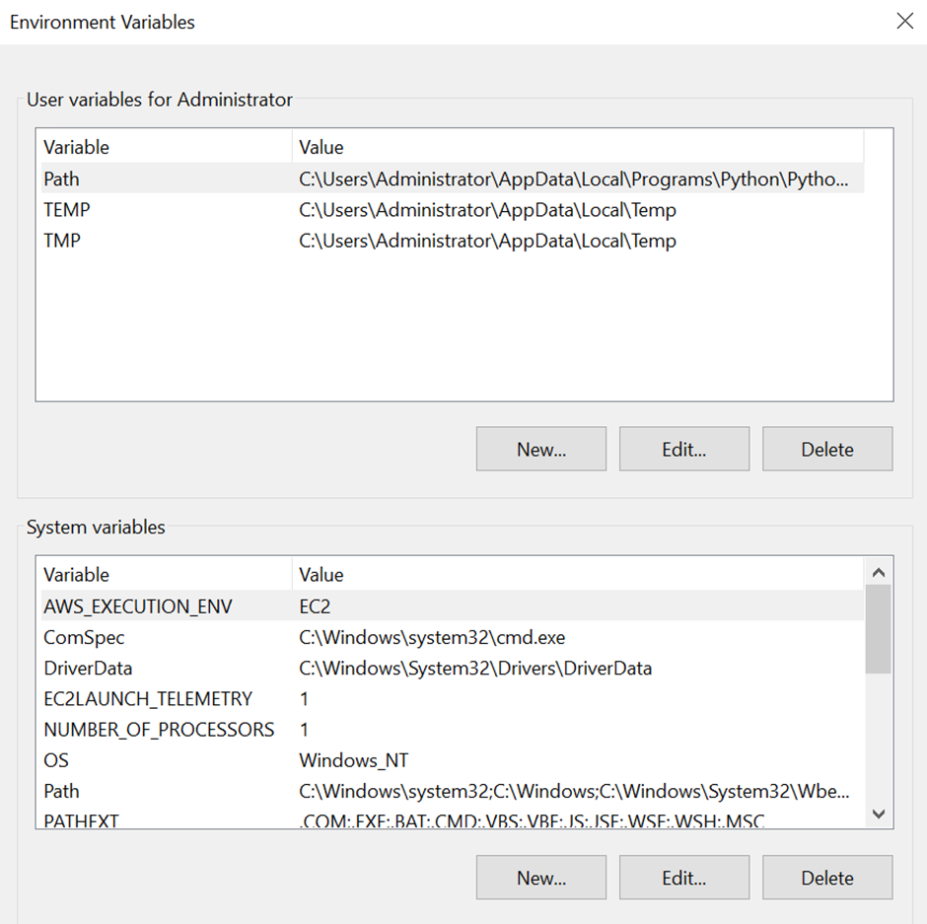

Copy the second path and click cancel:

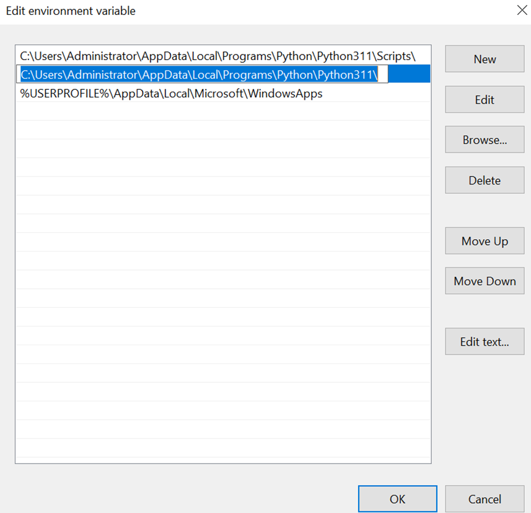

Under system variables:

Double click Path

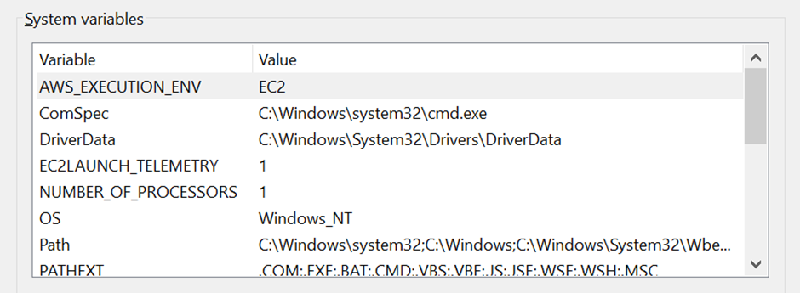

Click the New button, then paste the link in the new area and click Ok:

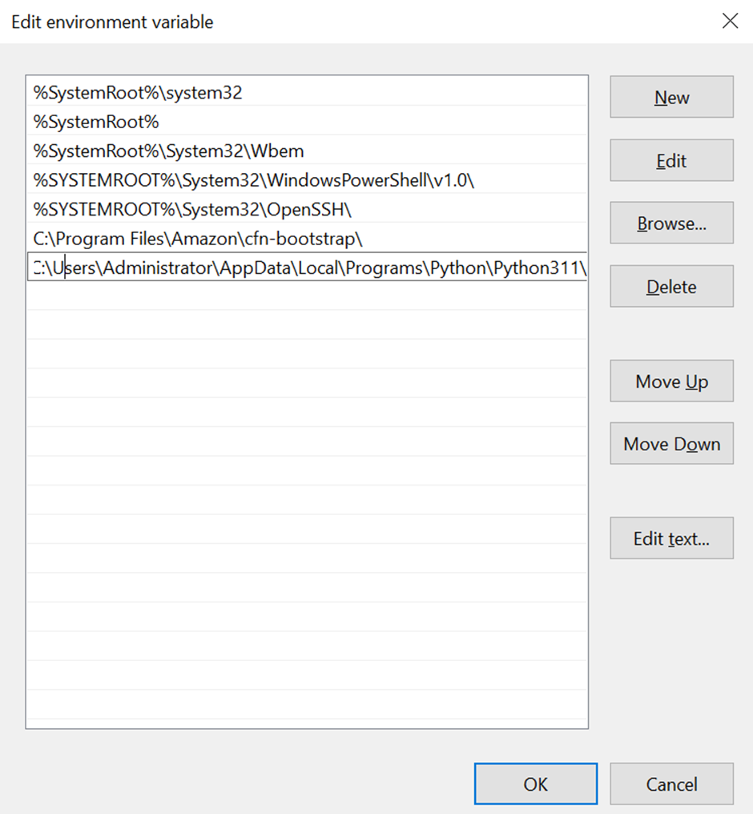

Click Ok for environment variables:

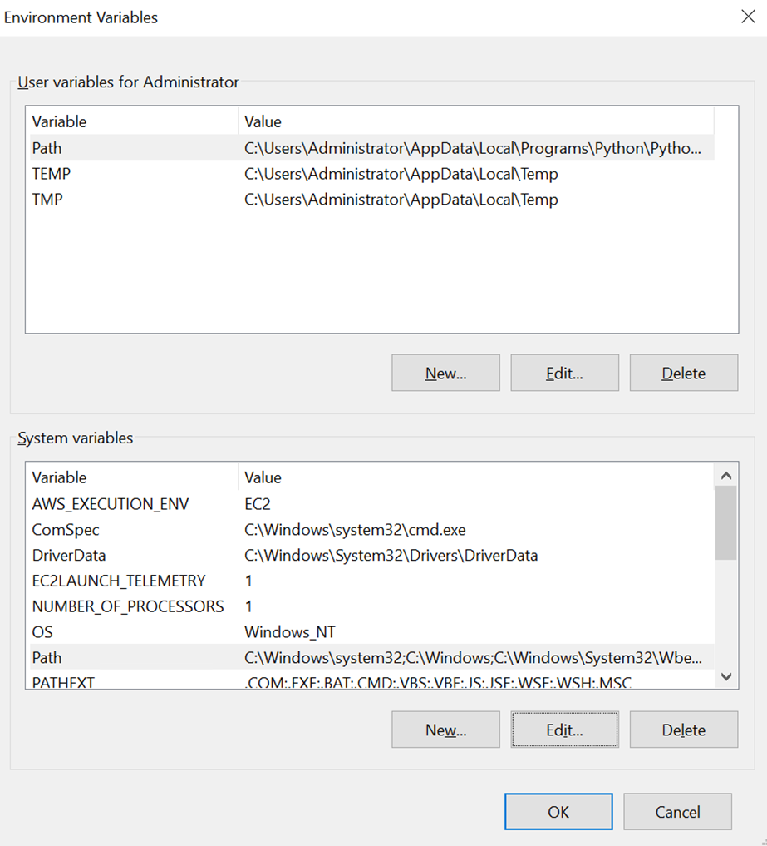

Close the window of System Variables

Open xampp, turn off Apache and MySQL, click config under apache, and select PHP (php.ini):

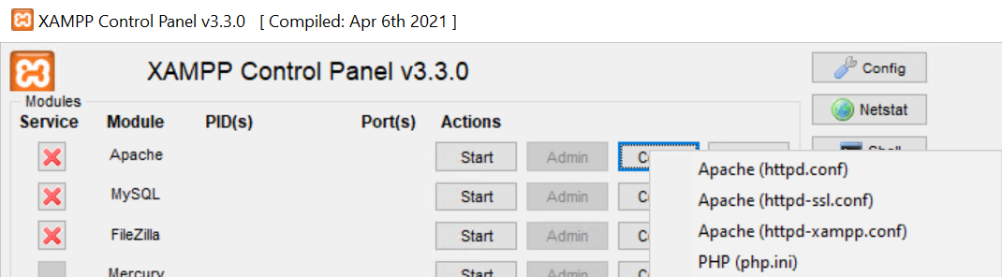

Find max_execution_time and change it to 2400:

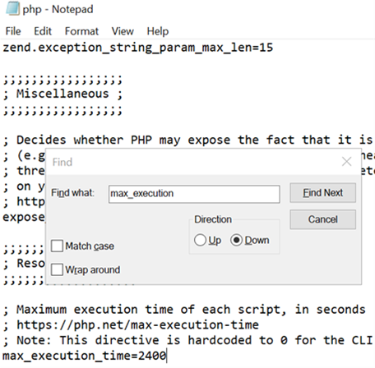

A txt file will open for php.ini and find zip once, remove the ‘;’ in front of extension zip and save the file:

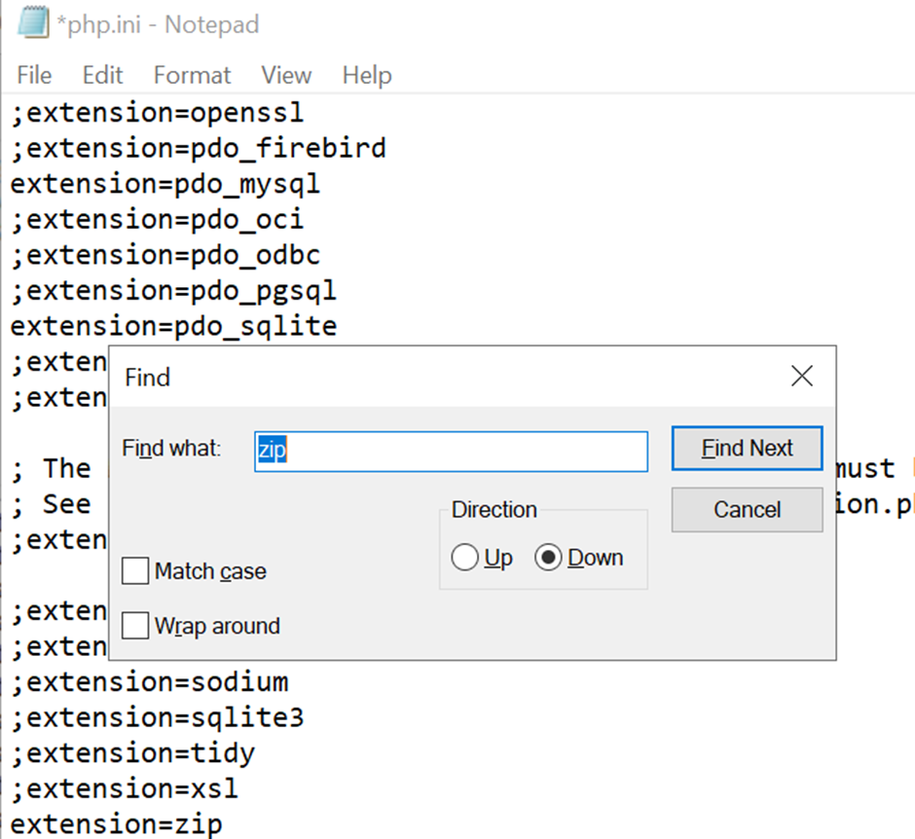

Click Config, then click Apache (httpd.conf):

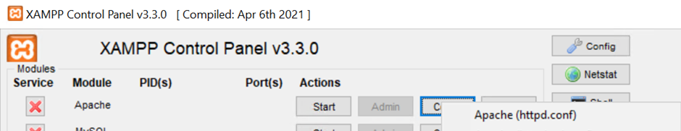

Search handle twice and type “ .py”, a space infront of .py in important and make sure you type it behind .asp:

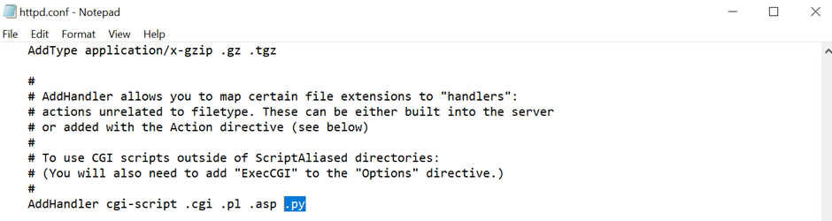

Use Edge to go to<https://visualstudio.microsoft.com/visual-cpp-build-tools/> and install

Click continue the installer.

unselect windows 11 SDK and select Windows 10 SDK:

Click install while downloading:

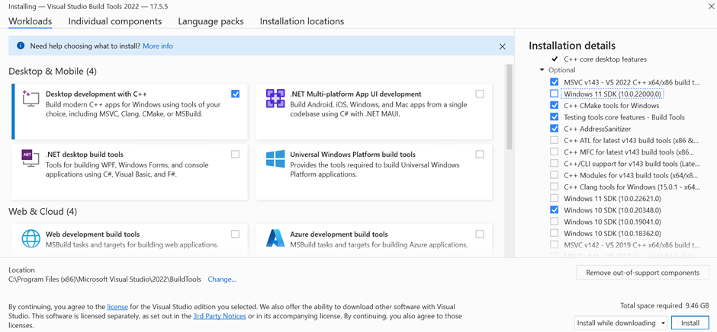

It should install without error and show:

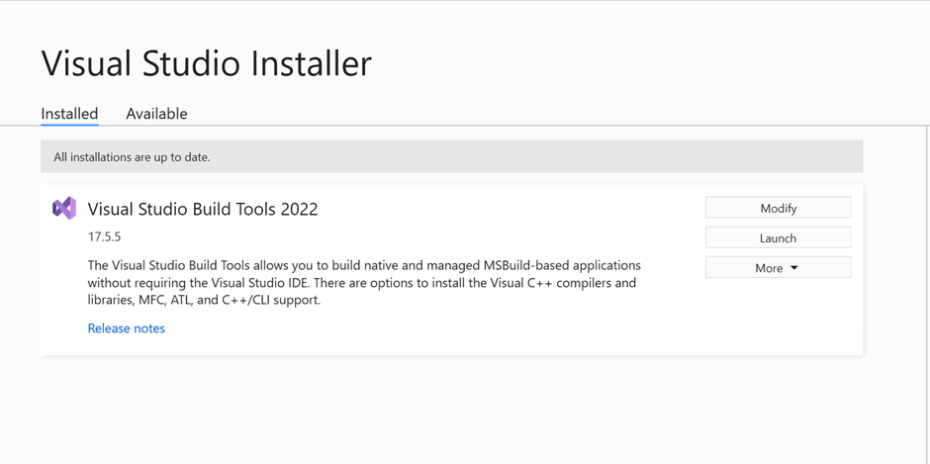

Open command prompt:

Type pip install scrapy:



pip install scrapy_user_agents



pip install pandas



pip install numexpr



pip install scikit-surprise



After all the installs, it will say successfully installed for each of them.

Open command prompt and type these “where python”:

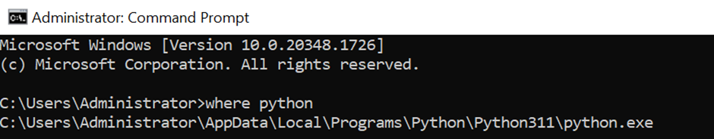

You should see the previous filepath appearing.

Download source code, unzip, and copyFYP folder, then paste into C:\xampp\htdocs\dashboard:

Start xampp and Start apache and MySQL.

Click “Admin” button for MySQL:

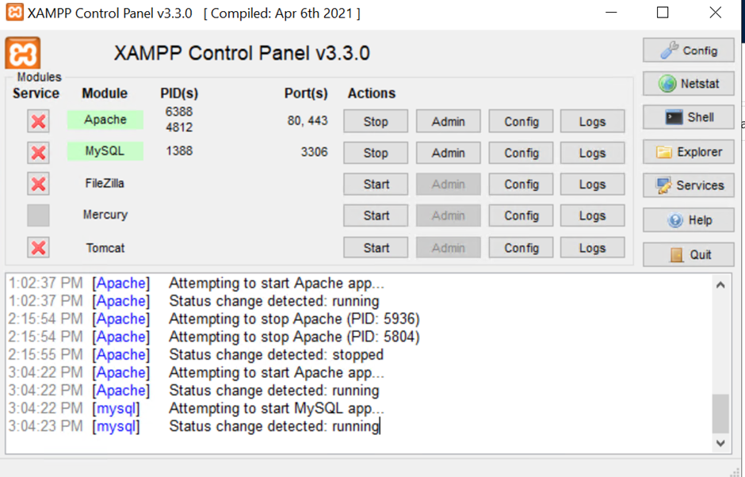

Create database called FYP:

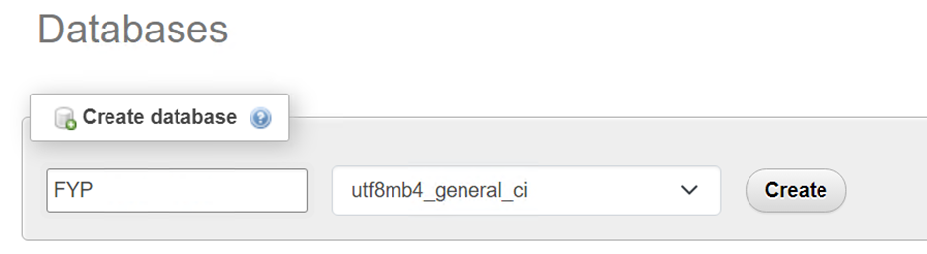

Select Import, then select FYP.sql in C:\xampp\htdocs\dashboard\FYP\Database:



After importing, there will be Events and Tables under fyp:

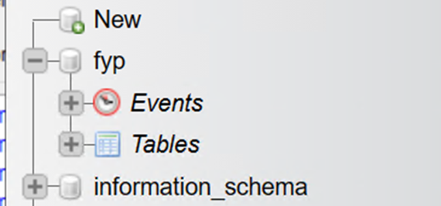

Get composer:

<https://getcomposer.org/>

Install for all users:

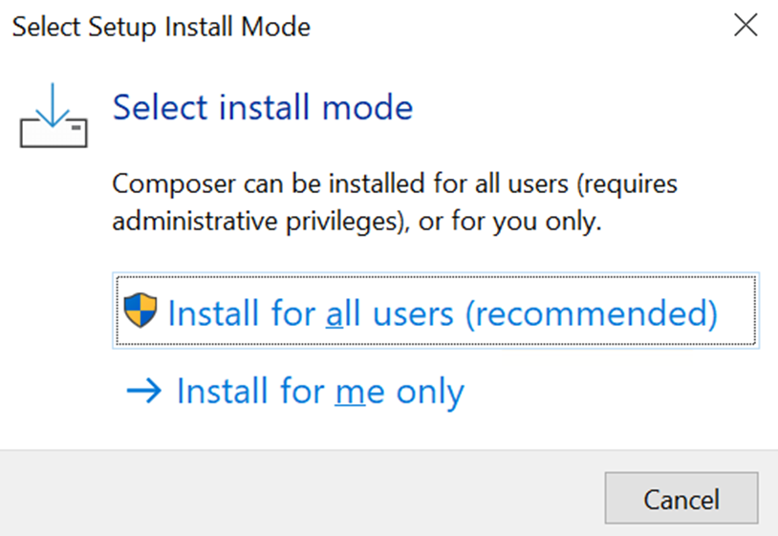

Click next:

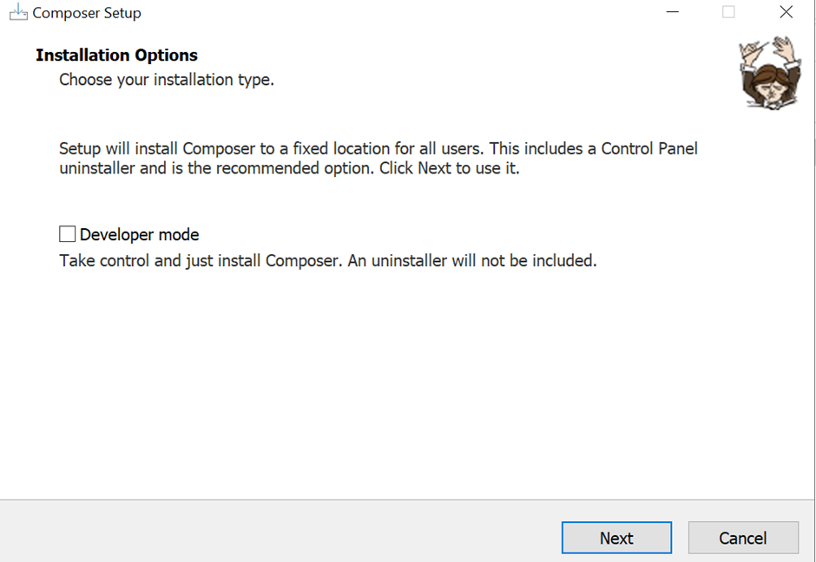

Click Tick “Add this PHP”, and click Next:

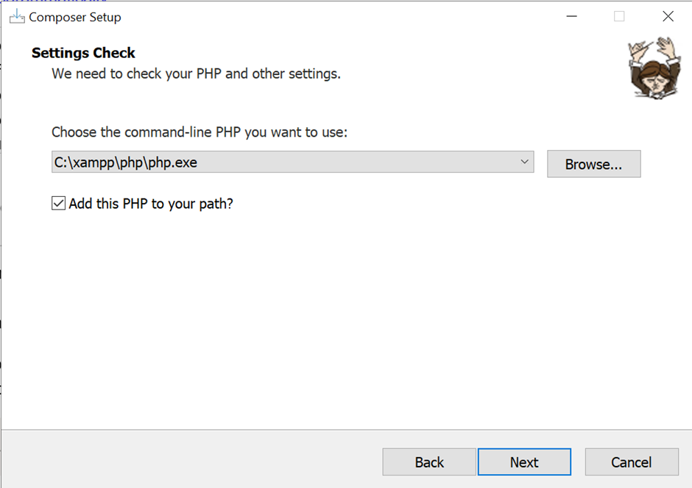

Click Next:

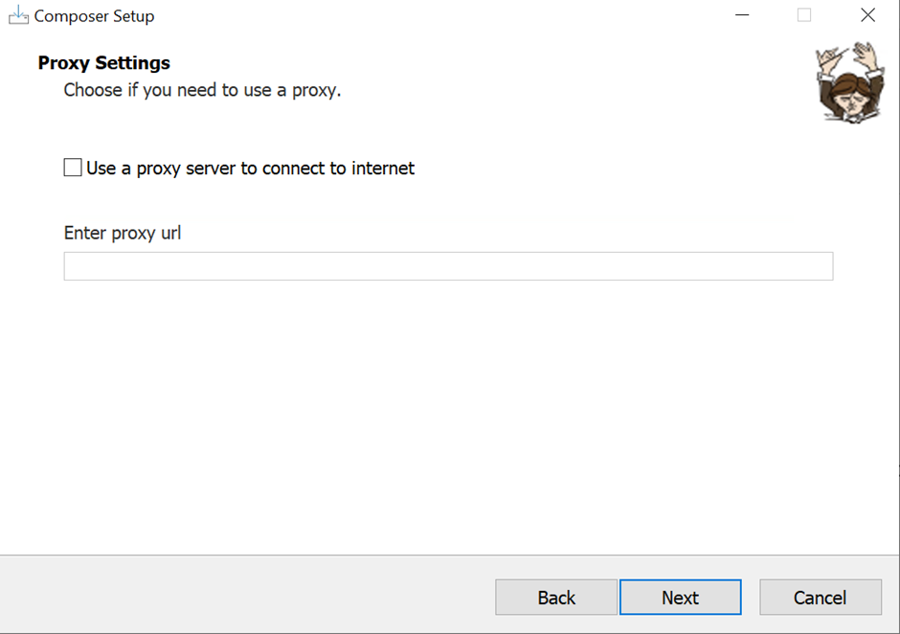

Click next and make sure to close all file explorer windows.

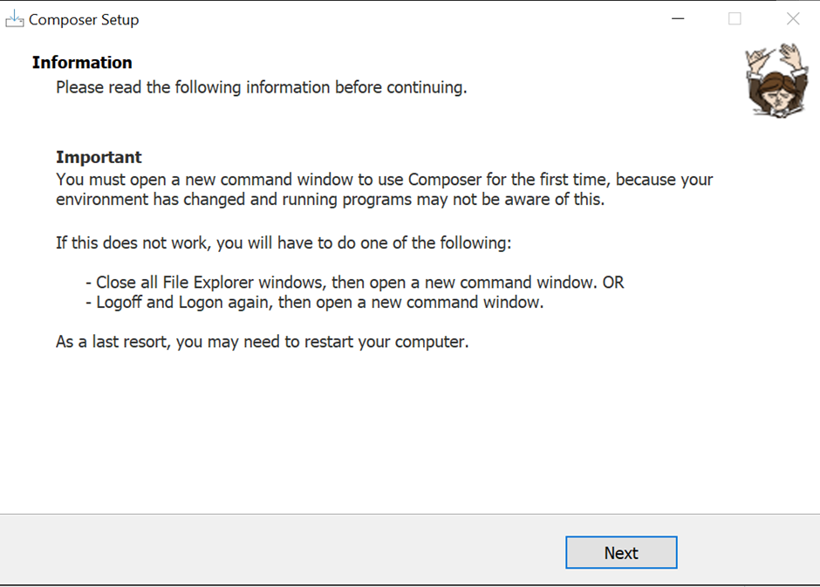

In command prompt, type in cd C:\Users\Administrator

Then run the command: composer require sendinblue/api-v3-sdk "8.4.2”

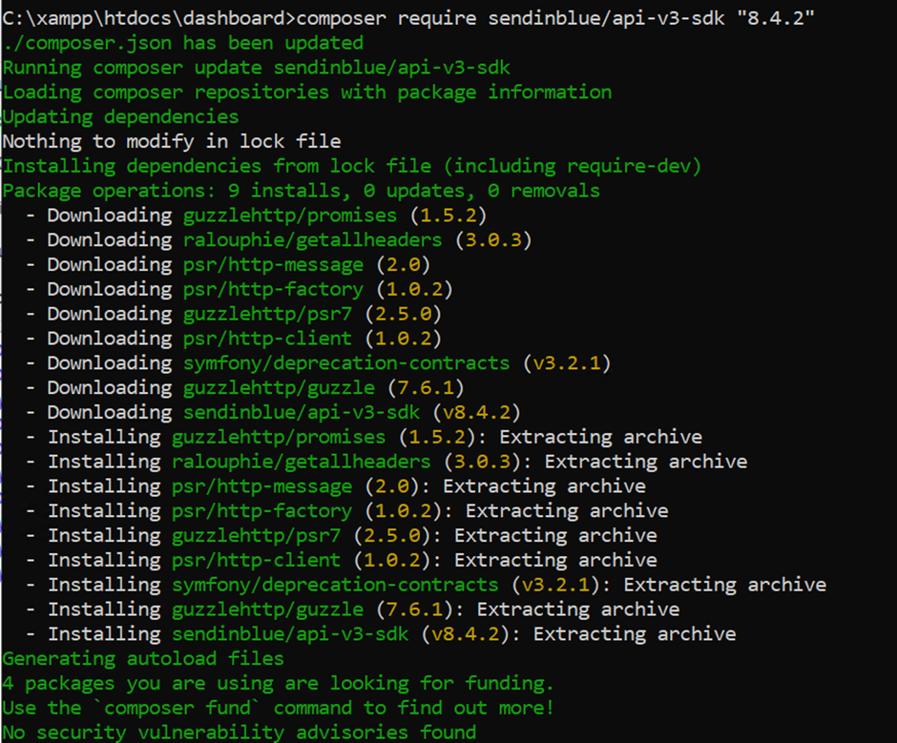

If you want to change the email address for the email verification, you have to sign up to Brevo below and follow the steps.

Sign up on<https://developers.brevo.com/> by clicking on My API Key:



Verify your email and sign in, click the icon on the top right corner:

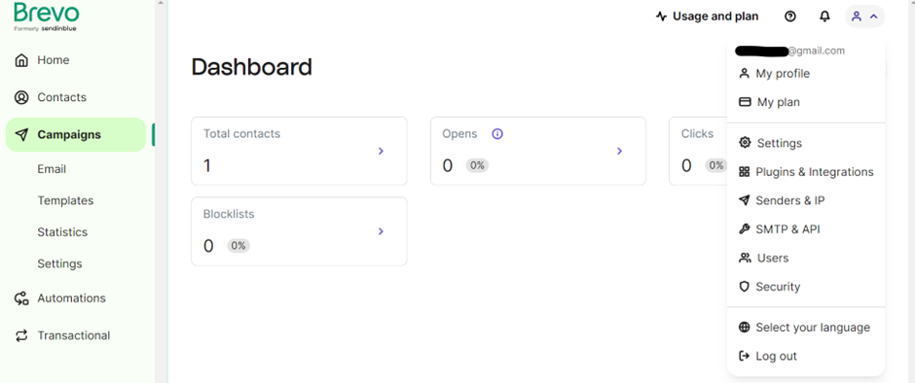

Click API Keys:

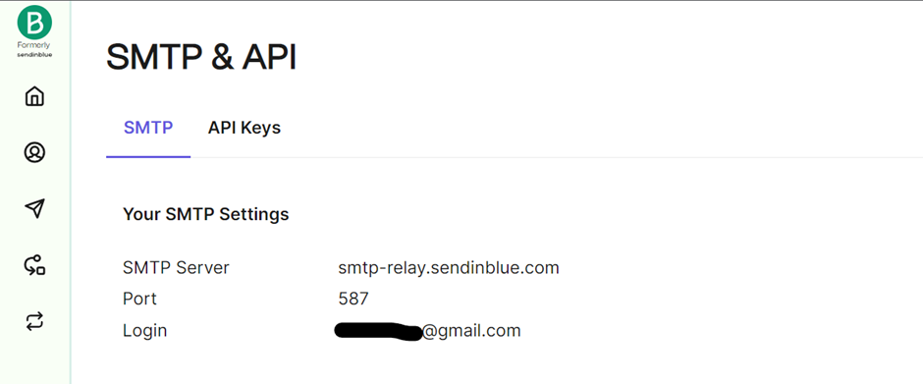

Click “Click here” to generate API key:

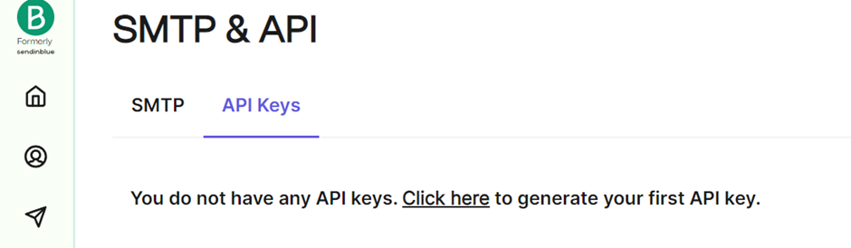

Type fyprecs and click generate:

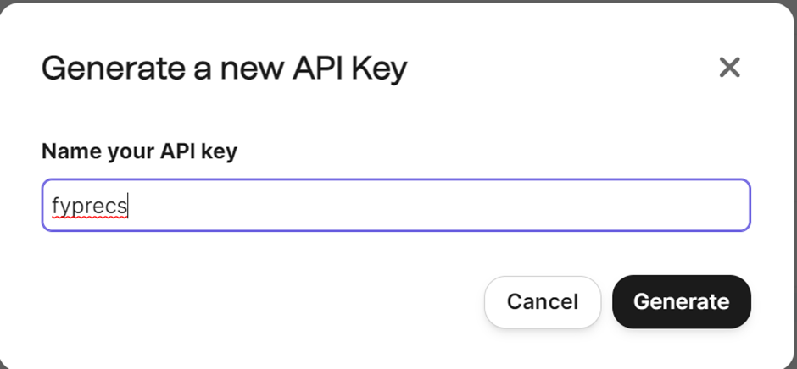

Copy the API key and save it inside a txt file:

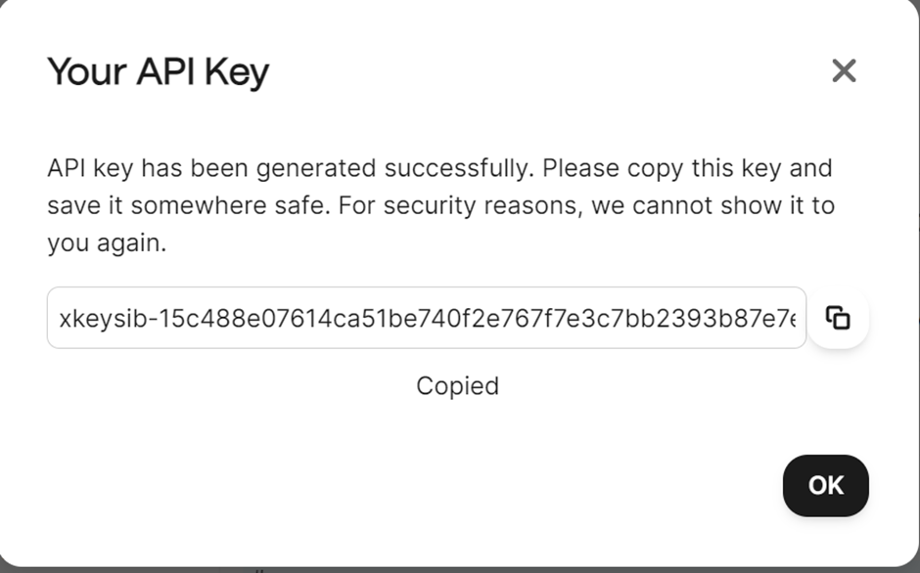

Copy this API key into login.php and email_verification.php by searching apikey, change the email to the email you created on Brevo in C:\xampp\htdocs\dashboard\fyp folder:

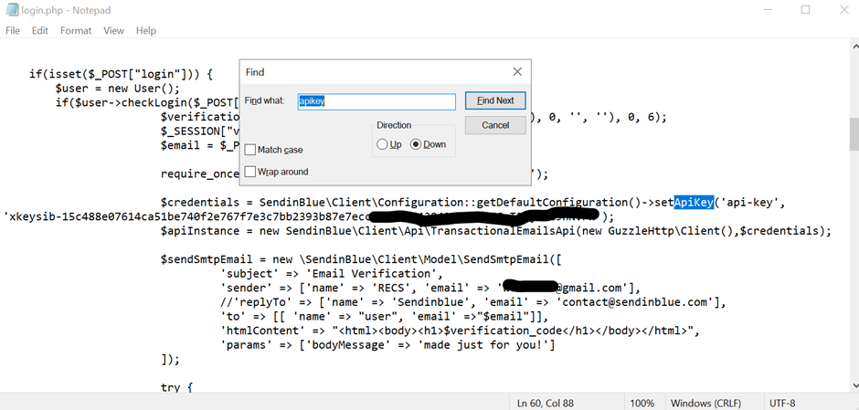

Find task scheduler on the windows search bar:

Right click on task Scheduler library and click Import Task…:

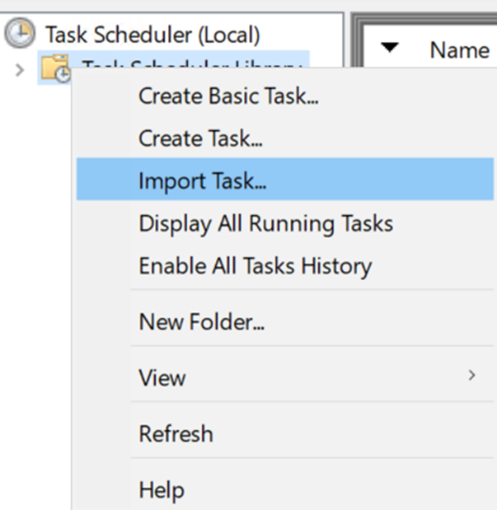

Head to C:\xampp\htdocs\dashboard\fyp\neuralcrawling\neuralcrawling\xml file for task scheduler:

Double click run computers-cmds:

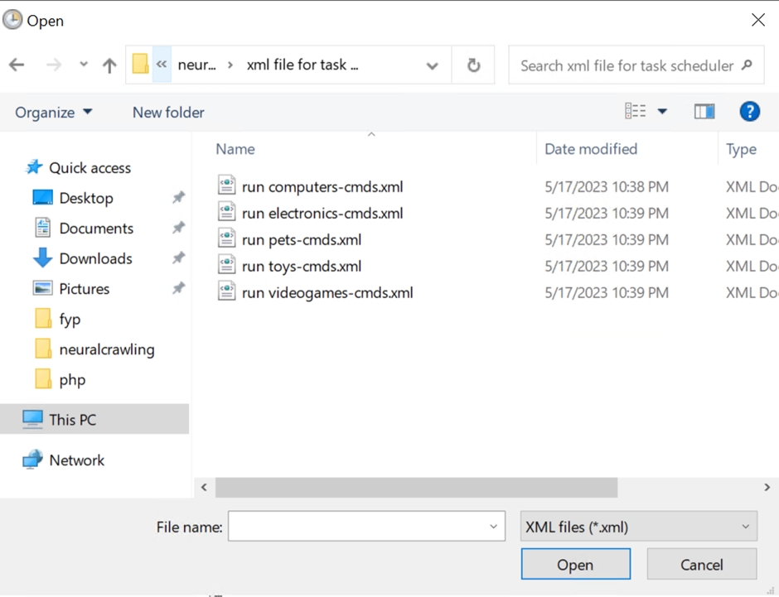

Click on run computers-cmds.xml first, it will pop out this Create Task:

Click ok:

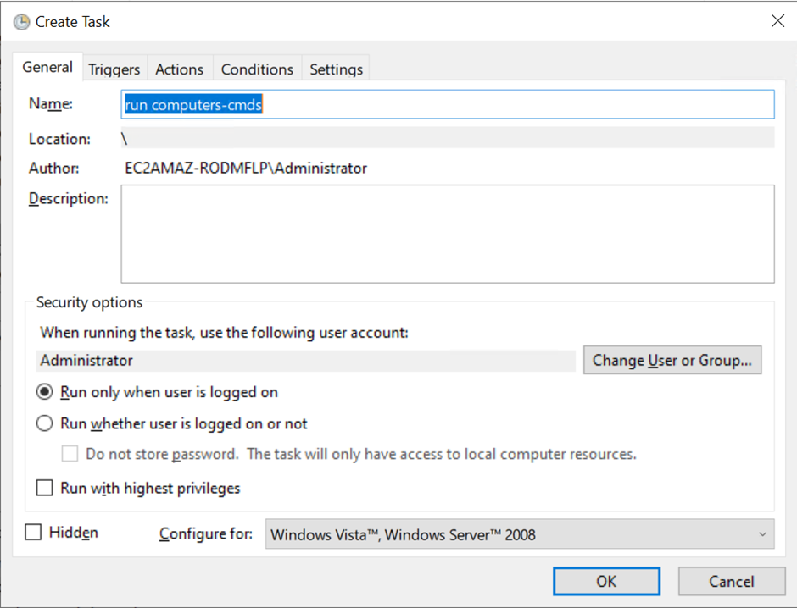

Repeat the previous steps 4 more times for the remaining files like run electronics-cmds.xml, run pets-cmds.xml, run toys-cmds.xml and run videogames-cmds.xml.

This should be the schedule for the scraping to occur at daily at night:

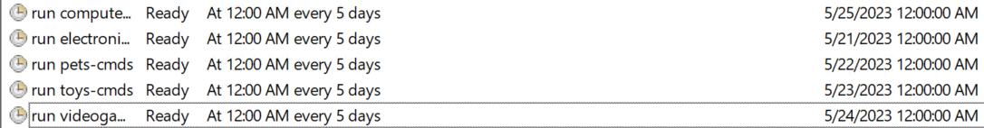

Skip this portion if you are able to upload the xml in the previous portion:

Manual way of creating basic task if the xml file fails to upload:

Click on task scheduler library and create basic task:

Type run pets-cmds (change if necessary)

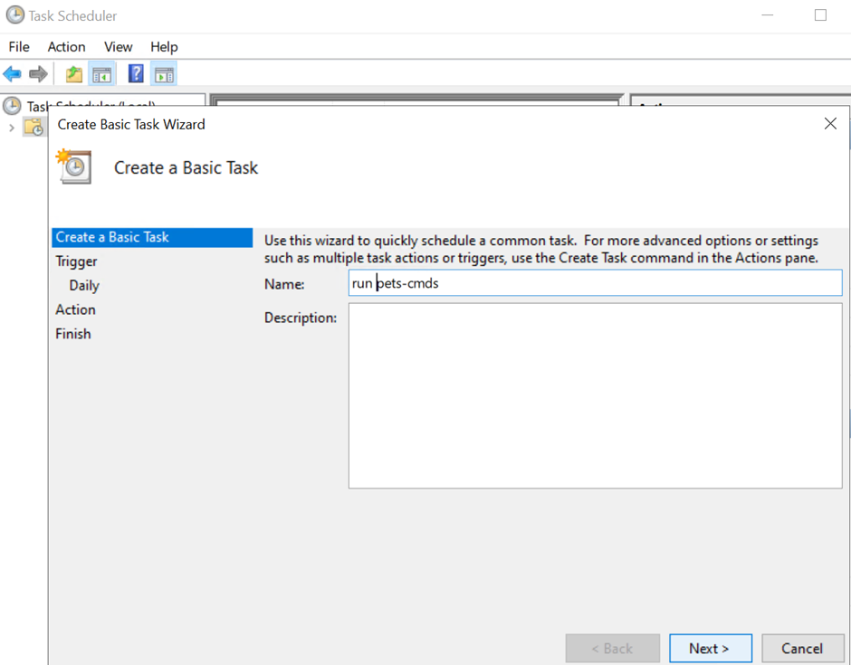

For pets, select Daily, click next:

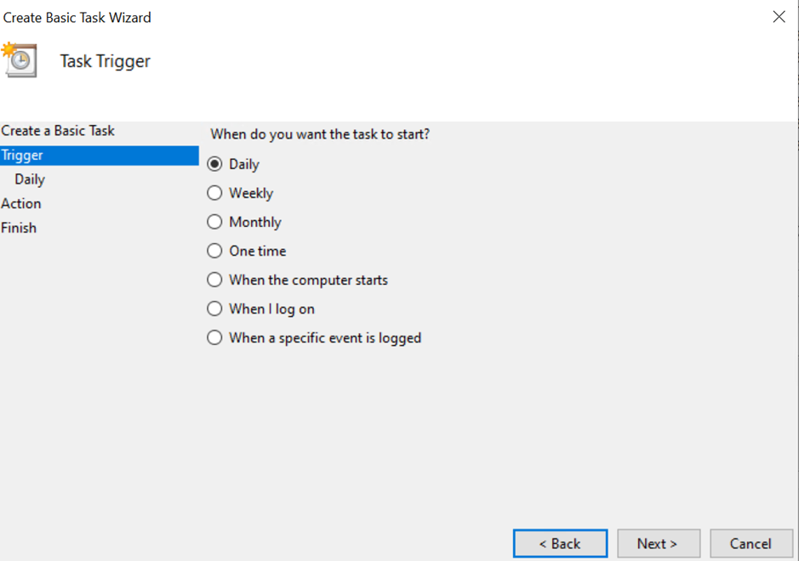

Set the time to 12:00:00AM, move the start up by one day everytime you do for the next few category and click next.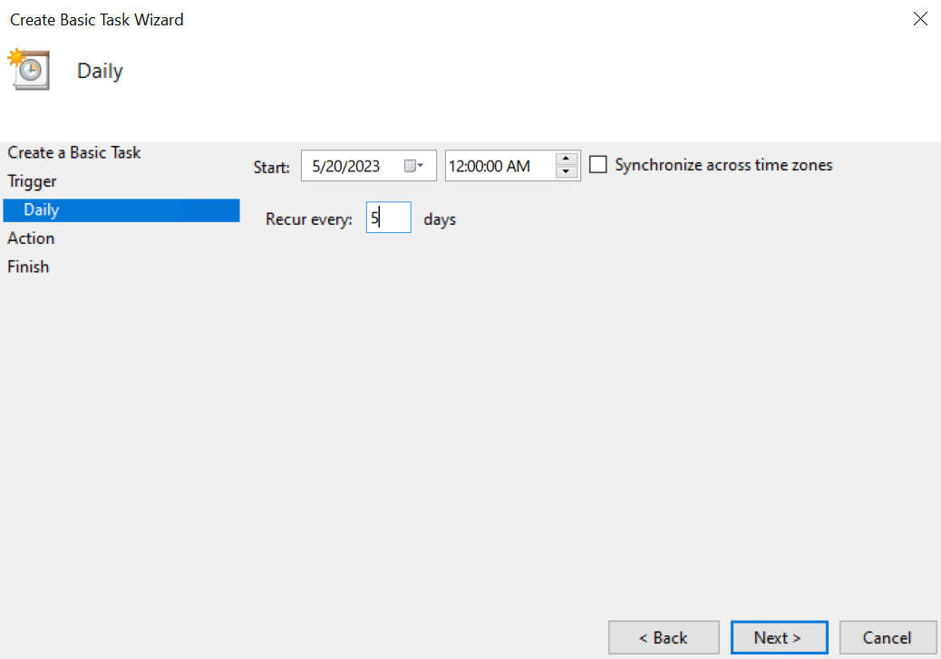

Start a program and click next:

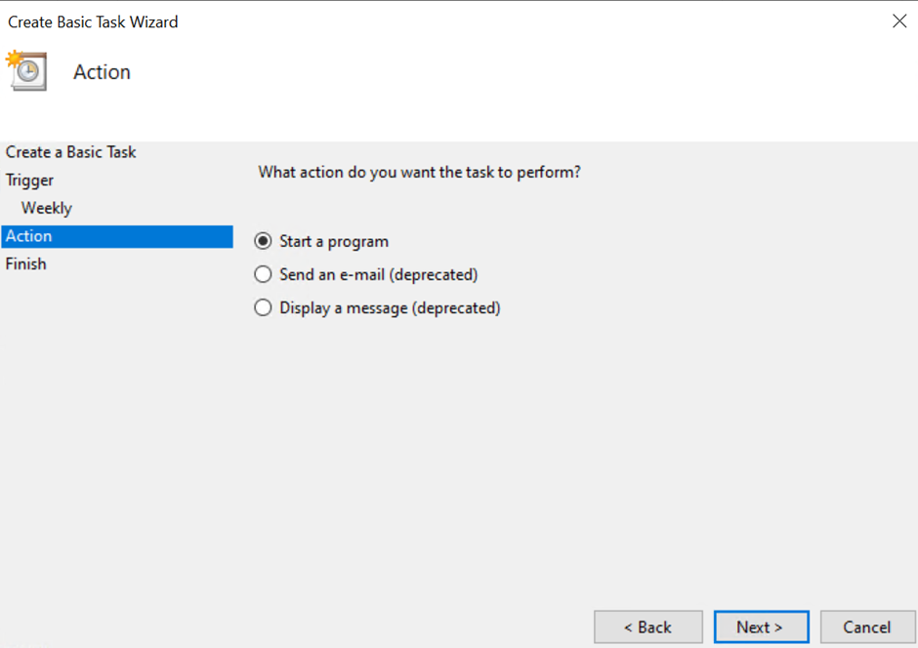

Browse to C:\xampp\htdocs\dashboard\fyp\neuralcrawling\neuralcrawling\pets-cmds.py (change the py file if necessary)

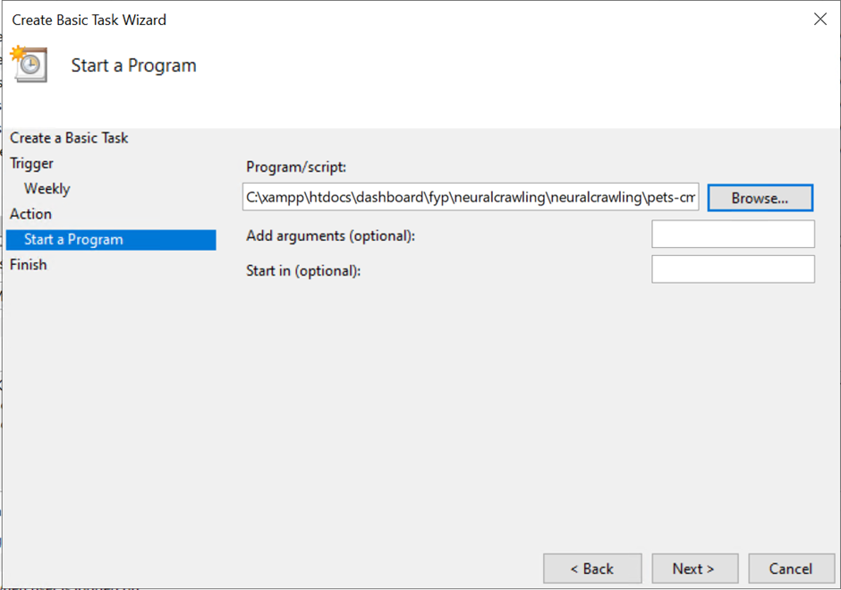

This should be done 4 more times, for electronics-cmds, pets-cmds, toys-cmds, videogames-cmds all starting on different days.

This should be the schedule for the scraping to occur at night:



You should delete the installer files that are in the download folder using file explorer.

After deleting, right click on recycle bin and click Empty Recycle bin:

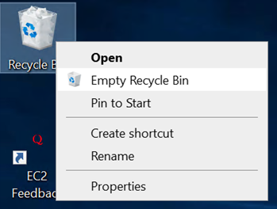

Close all file explorers and notepad, except Xampp control panel, do leave the Apache and MySQL on for the website to function.



You should be able to get http://<>/dashboard/fyp/main.php, replace <> with either the public IPv4 DNS

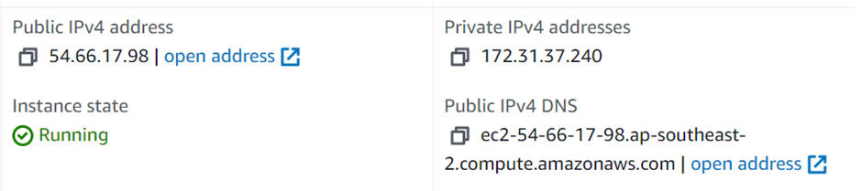

You will be able to access the website from your google chrome:

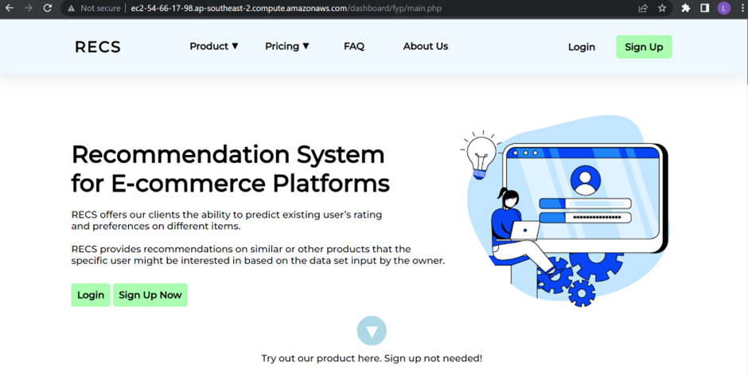

You could create a url by heading to this website https://app.bitly.com/ and copy pasting the link from above and click create new, link, then paste the destination and click create:

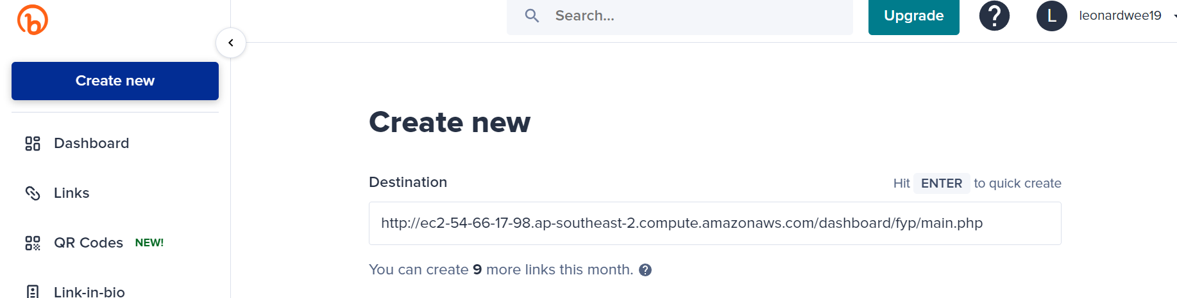

## 

## Workflow 2

### Account creation – Sign up via email:

Clicking Sign Up Now or Sign Up.

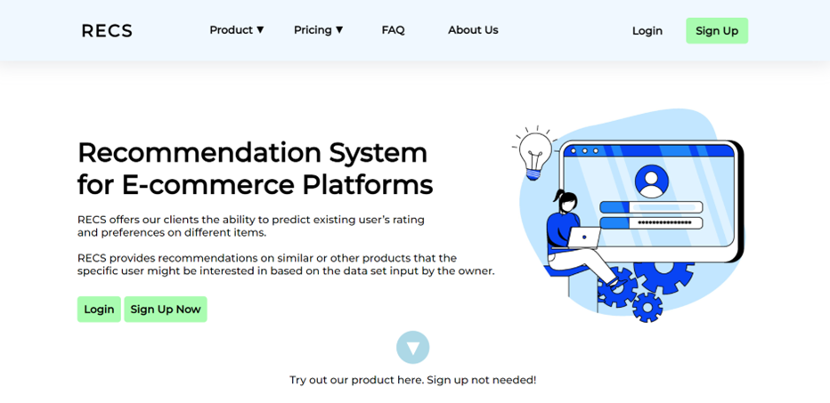

You could either sign up as an Organization or Individual:

Organization:

Fill up details if you are an Organization:

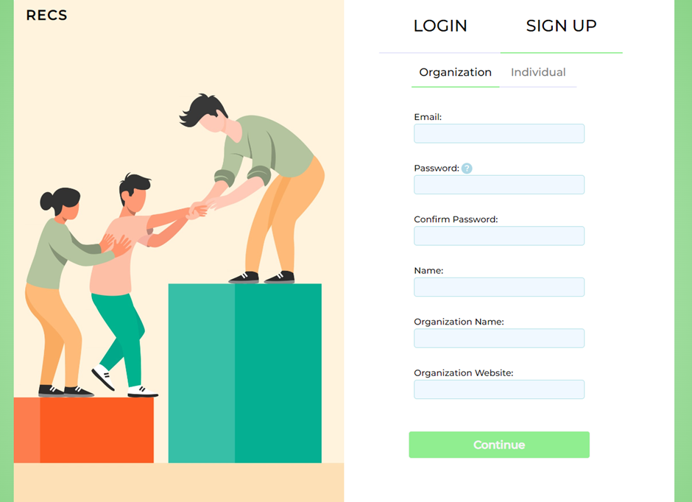

You will be asked to select what type of item you will be selling, you can select up to 5, then click sign up, for this screenshot below, I selected Electronics and Toys:

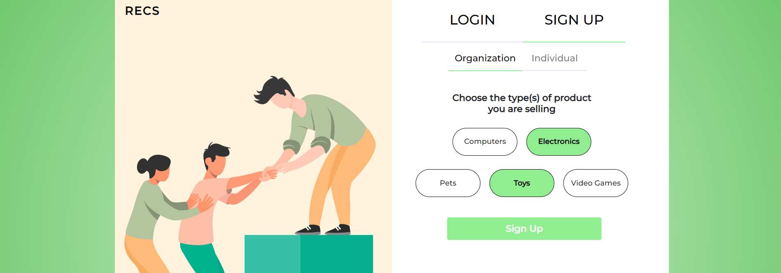

Verify your email by checking the email you signed up with:

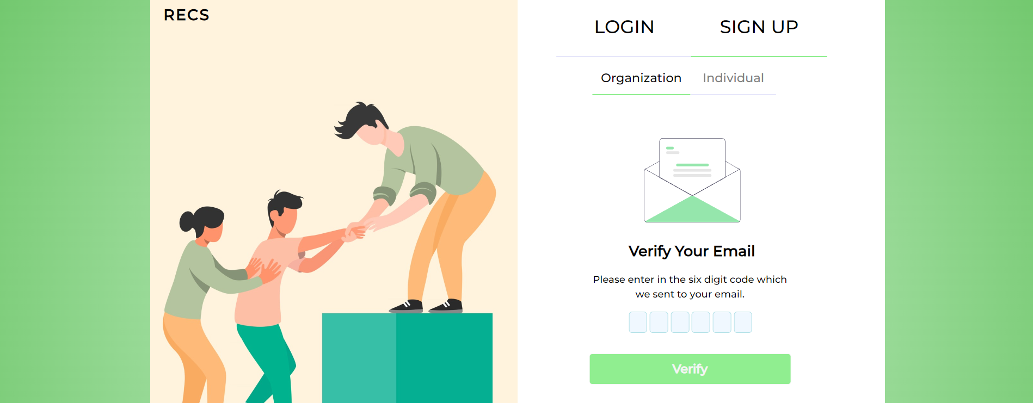

Individual:

Fill up details if you are an Individual:

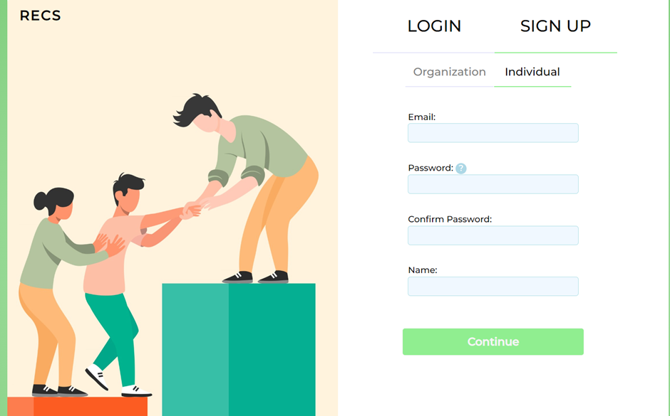

After the typing all the information required, you will be asked to choose an interest(s):

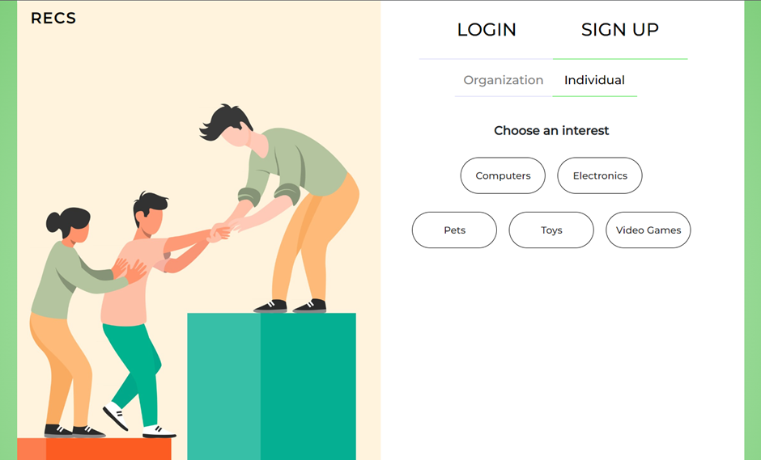

After clicking up to 5 interests, you will be prompted to sign up, the example below has 3 selections active:

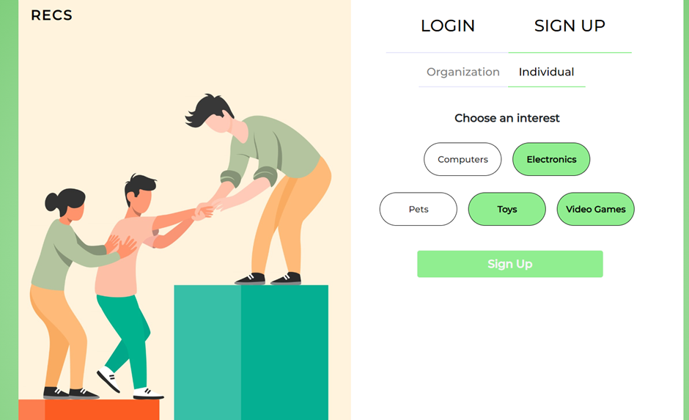

You will have to verify that the email address you input is valid by typing the code that is sent to the email address.

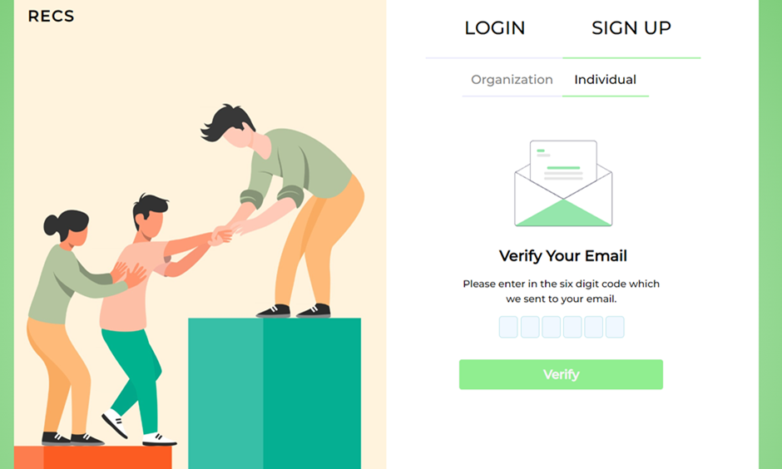

It will say account successfully created after you verified:

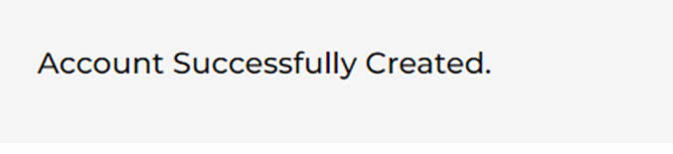

### Log In:

Type in email address and password:

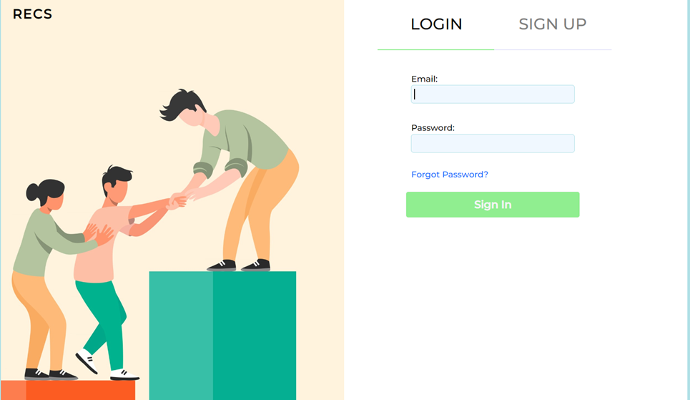

Verify by typing the OTP from your email address:

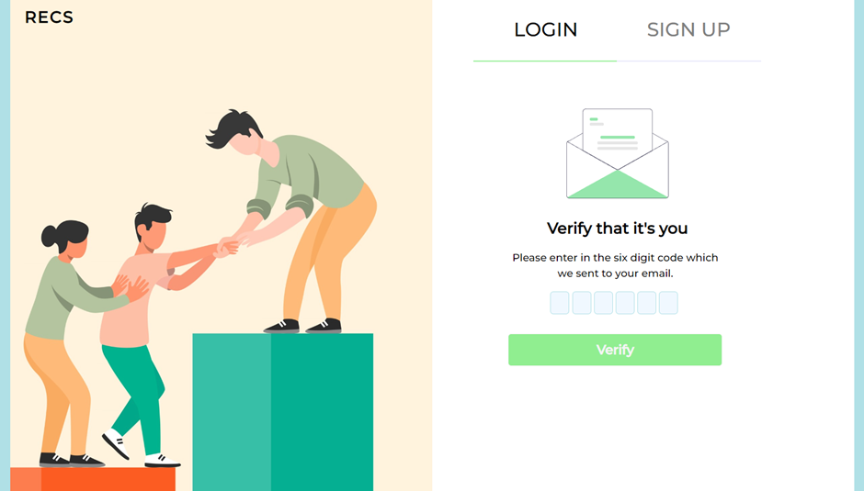

At the main page after logging in:

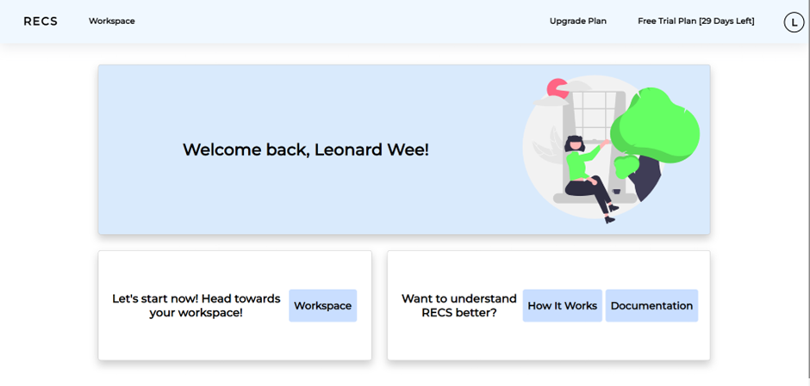

### Tabs in workspace:

#### Organization:

##### Discover Tab:

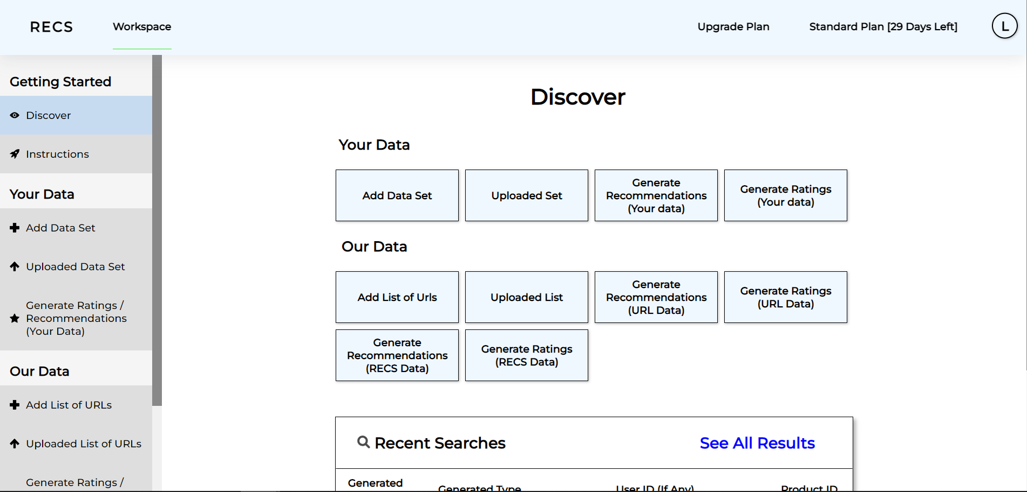

##### Instructions tab:

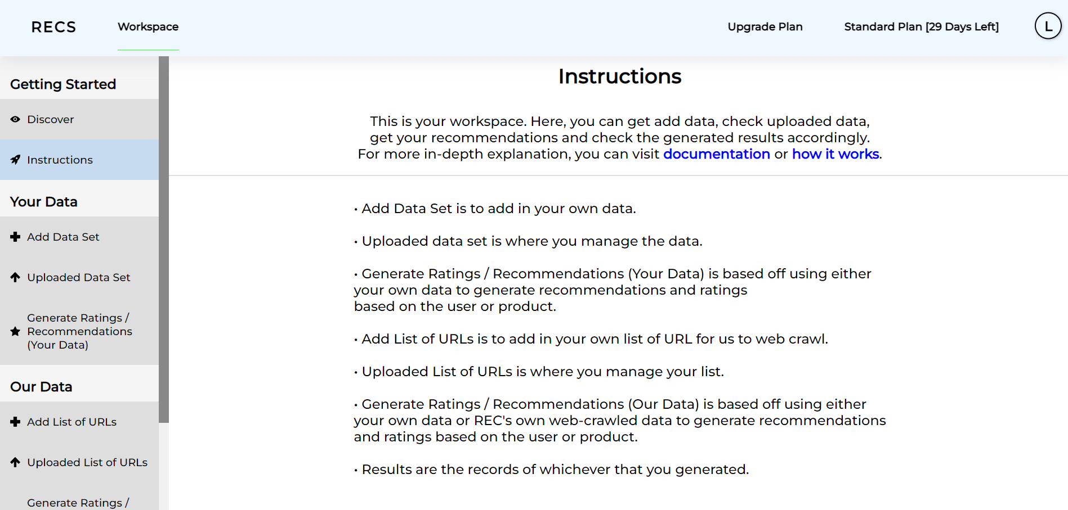

#### Your Data:

Before adding a csv file, please follow the rules below:

1. Each .csv file should include the category in its filename. The categories allowed are electronics, computers, pets, toys or videogames in lowercase.
2. Only one category is allowed per file.
3. Only Amazon.au links are allowed.
4. File format has to be followed strictly. This means it should include userID, prodID, rating, domain, image_urls and prodname.
5. There is an example to show how it should look like by clicking on “example”

After following those rules, you can upload a csv file.

### 

After uploading the data, you can see the data appearing in the next tab, the example below shows that electronics.csv is uploaded:

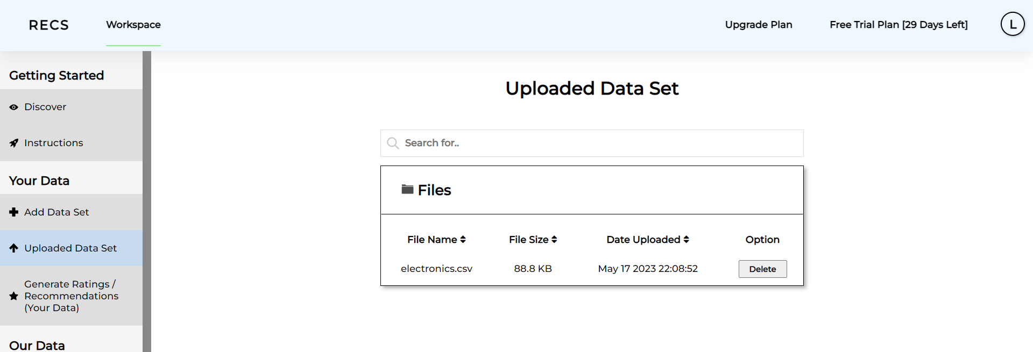

Generate Ratings / Recommendations (Your Data) tab:

Recommendations tab where you can input an amazon product ID to get recommendations of products using your data:

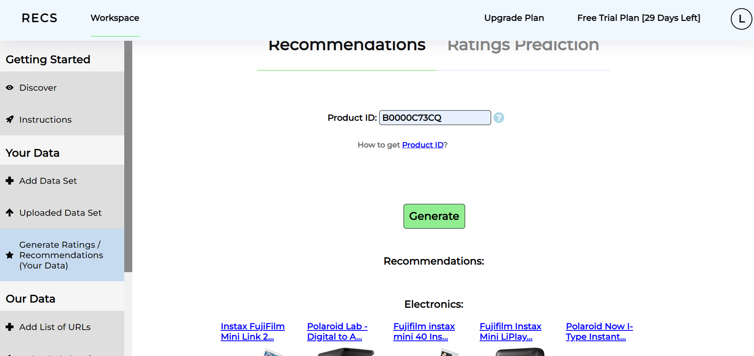

Ratings Prediction tab where you can input an amazon user ID and product ID to get ratings prediction using your data, after inputting a userID and Product ID, you can click generate the ratings prediction:

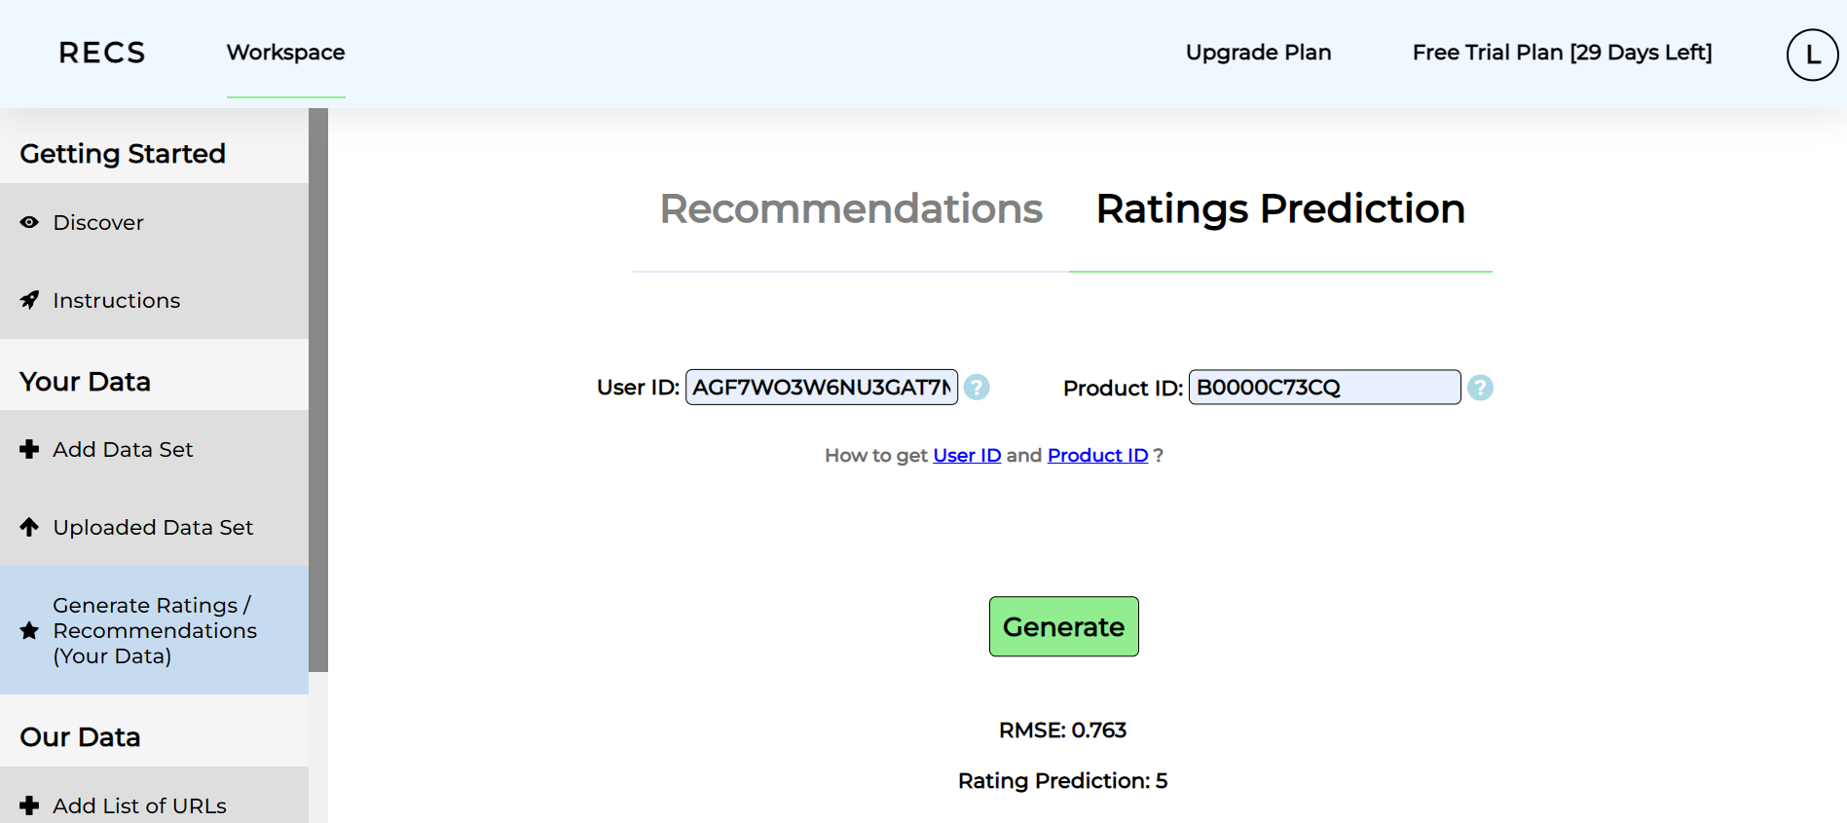

#### Individual:

##### Discover tab:

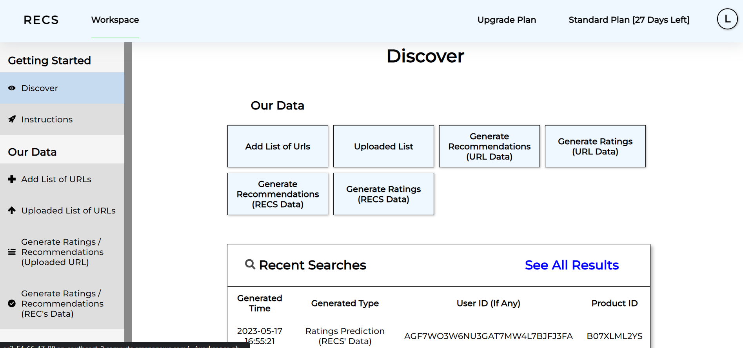

##### Instructions tab:

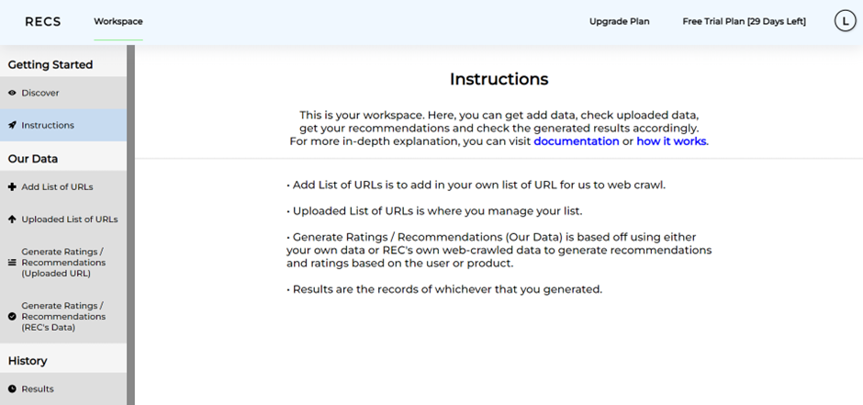

#### Individual/Organization tabs:

Add List of URLs tab:

Before adding a txt file, please follow the rules below:

1. Each .txt file should be of only one category.
2. Only Amazon.au links are allowed.
3. The first line of each file should be the name of the category in lowercase [electronics, computers, pets, toys, videogames]

Choose the file from your directory by clicking “Choose File”:

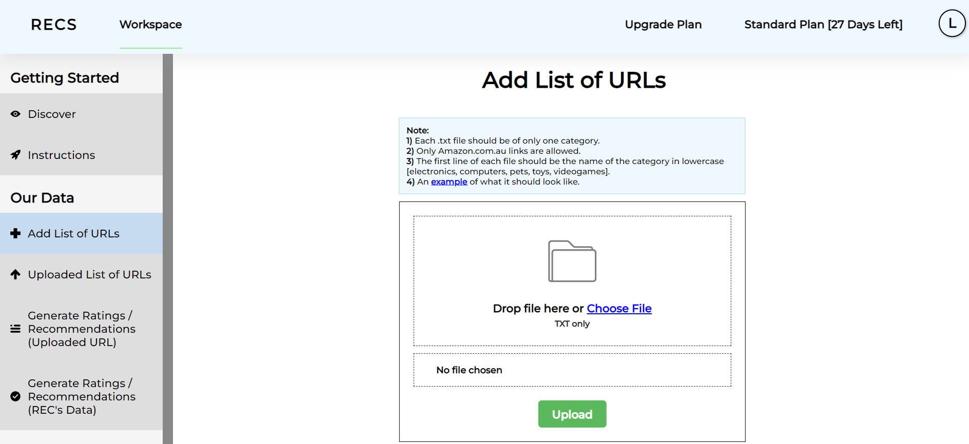

After uploading one it will lead you to the Uploaded List of URLs tab.

Uploaded List of URLs tab:

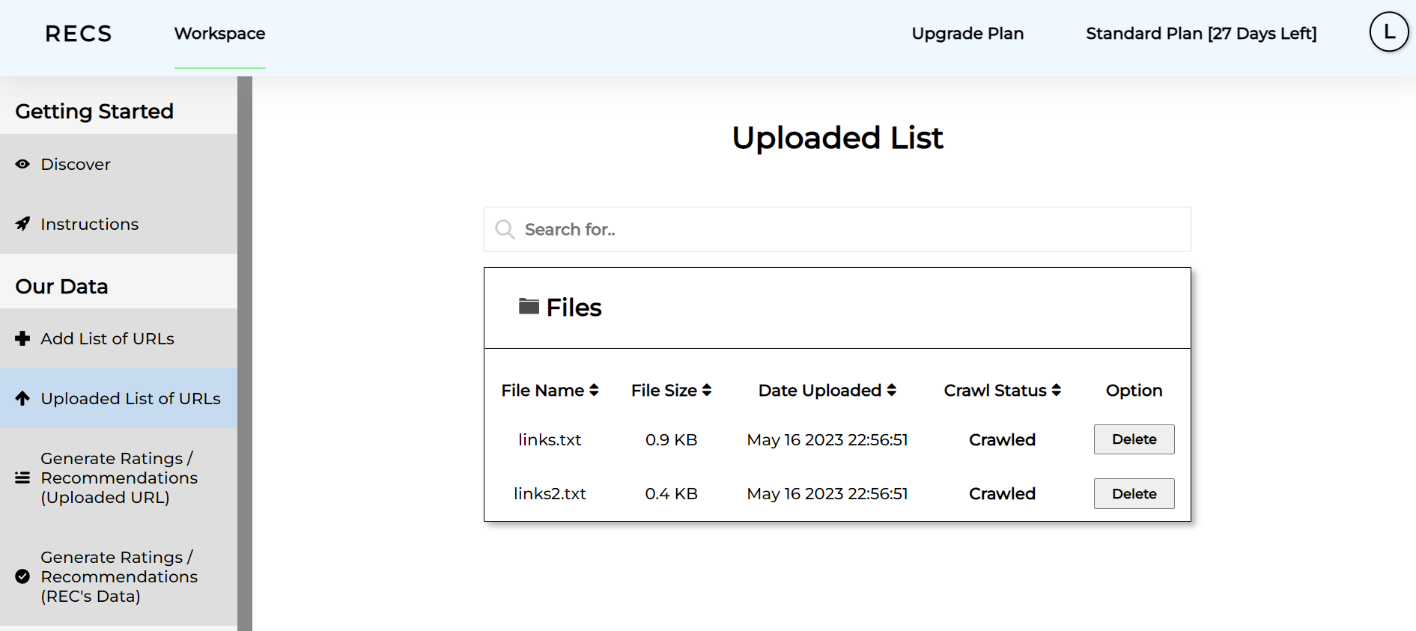

Generate Ratings / recommendations (Uploaded URL) tab:

Recommendations tab is where you can input an amazon product ID to get recommendations of products using a dataset that is from List of Uploaded URLs based on the category or categories that are selected, after input of product ID and clicking generate on the scraped items, it will provide electronics items recommendations.

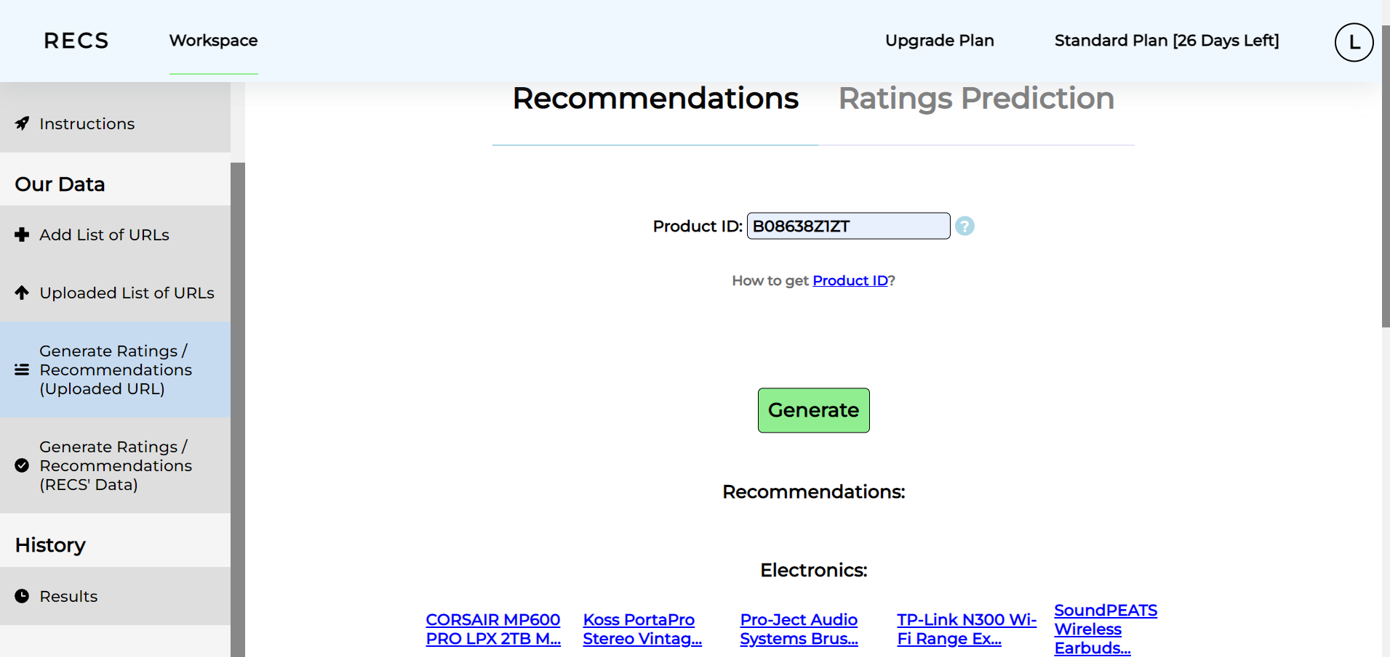

Ratings Prediction:

Ratings Prediction tab is where you can input an amazon user ID and product ID to get ratings prediction using a dataset that is from List of Uploaded URLs based on the category or categories that are selected after inputting user ID and product ID and clicking generate for svdpp to generate a ratings prediction, as shown below:

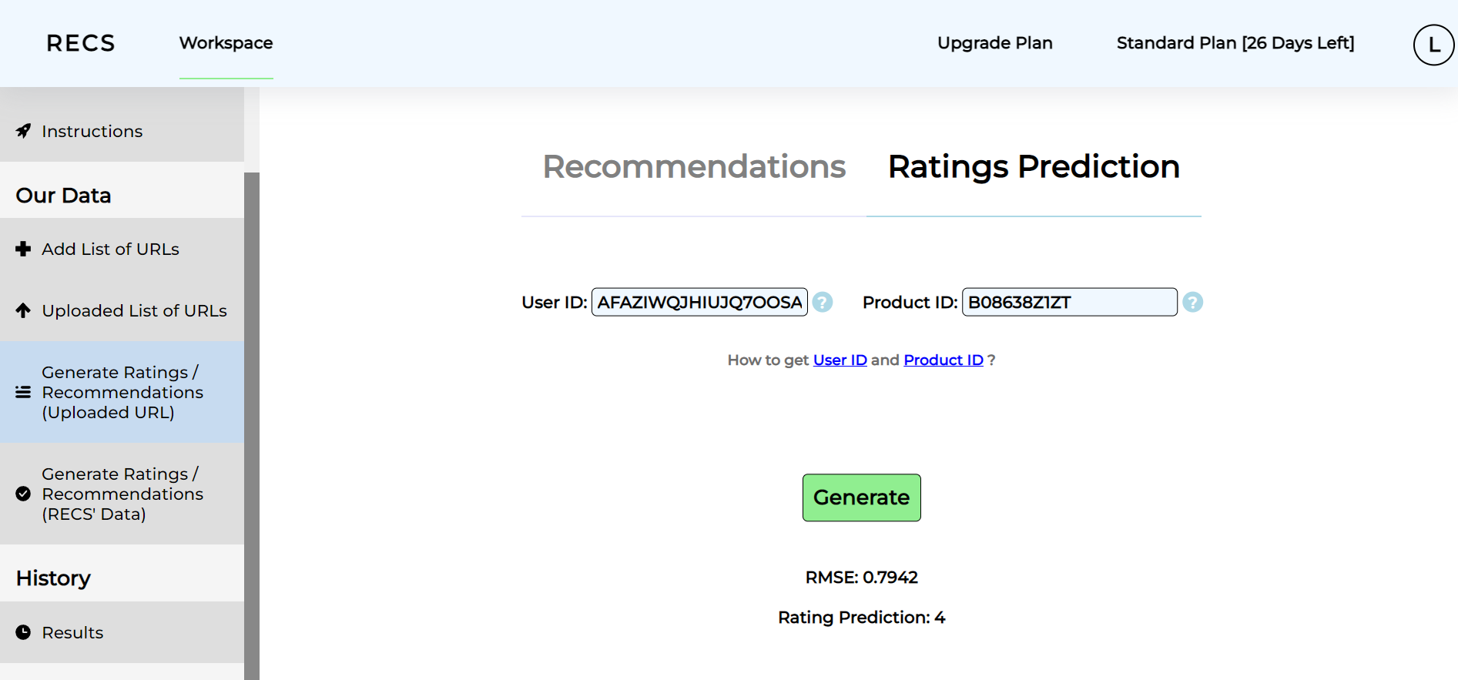

Generate Ratings / recommendations (REC’s Data) tab:

Recommendations tab is where you can input an amazon product ID to get recommendations of products from REC’s dataset based on the category or categories that are selected, after an input of product ID and clicking generate on the REC’s data, it will provide selected category recommendations.

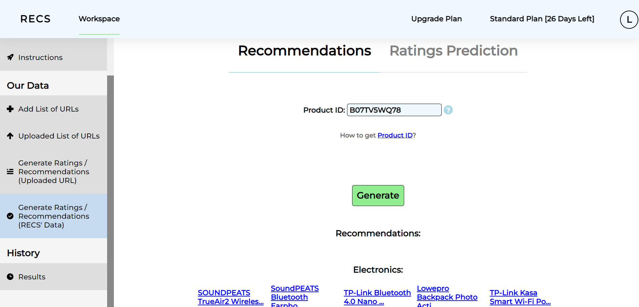

Ratings Prediction:

Rating tab is where you can input an amazon user ID and product ID to get ratings prediction from REC’s dataset based on the category or categories that are selected, after inputting user ID and product ID and clicking generate for svdpp to generate a ratings prediction, as shown below:

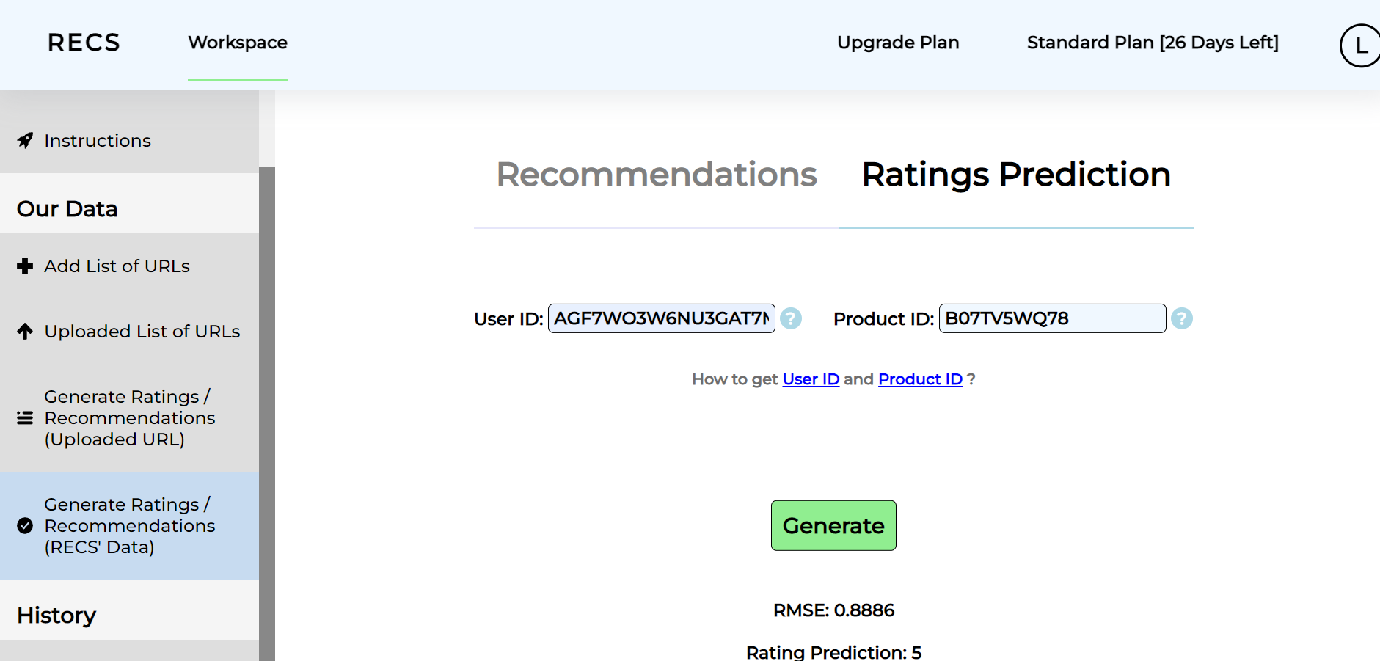

Results tab:

Shows the results for recommendations of products and the Ratings prediction of the previous tabs.

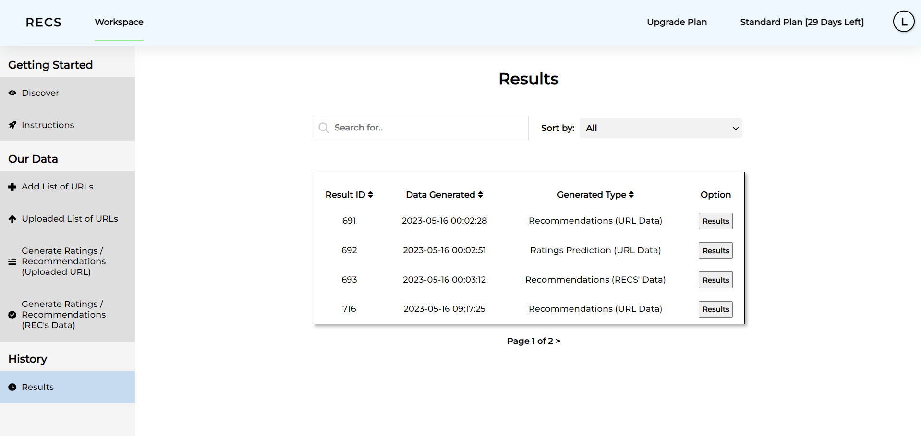

You are able to view the individual results in the Results tab:

You could use your middle mouse click upon hovering over an item to create a new tab to see the products on amazon.com.au:

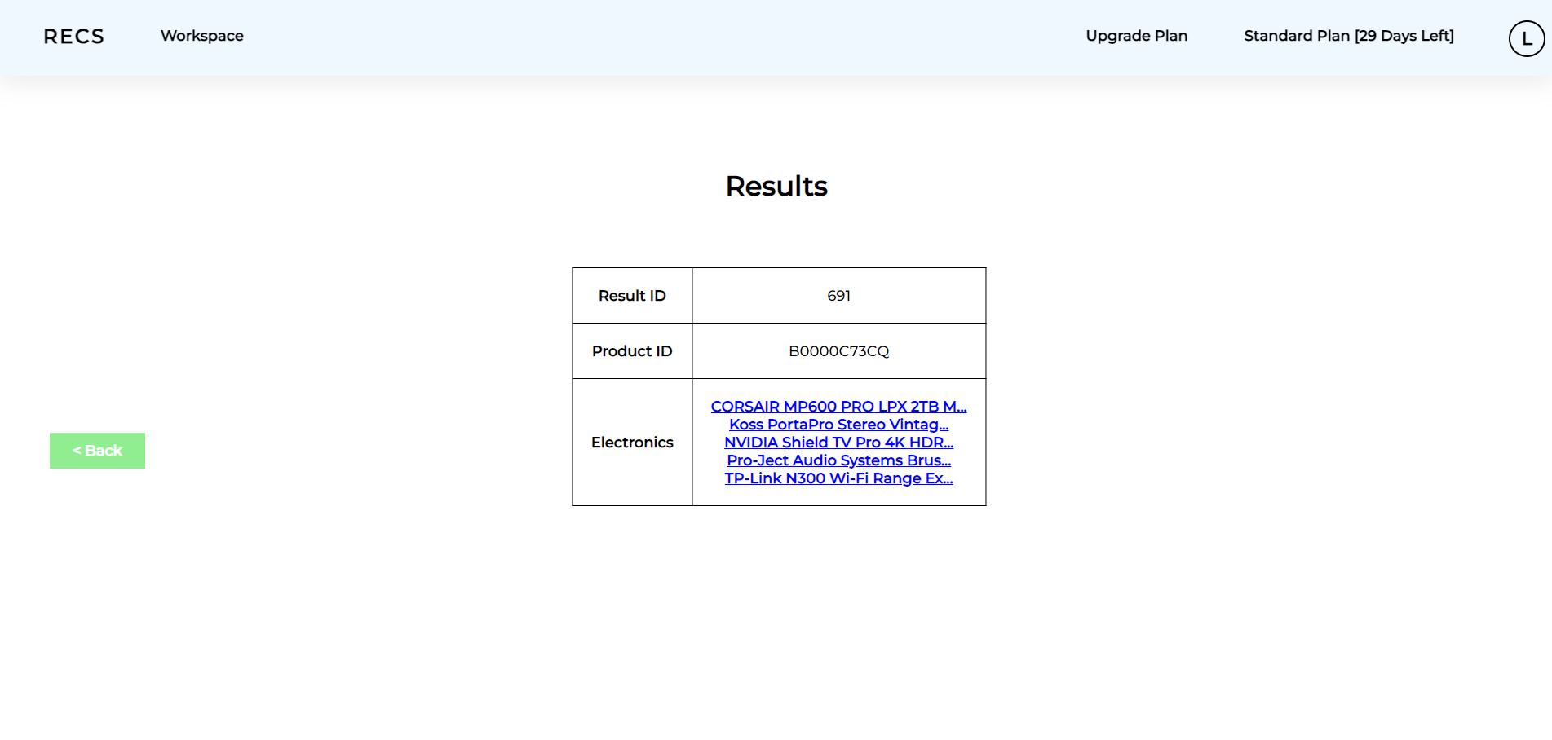

#### Upgrade Plan:

##### Individual:

Select either Standard ($9.90/month) or Pro plan ($34.90/month) for upgrade of plans.

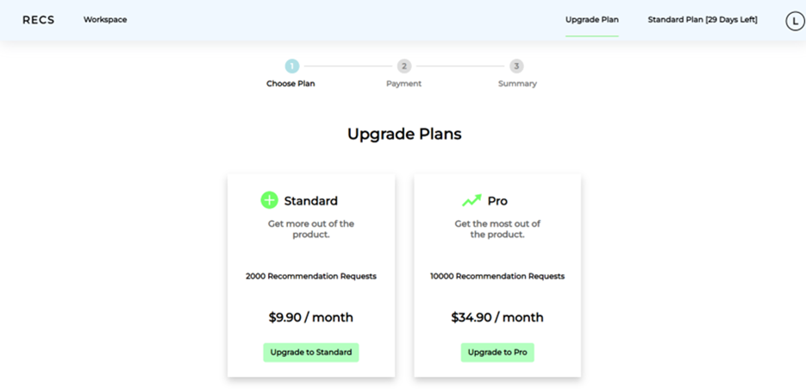

Upon selecting either of the options:

You have to key in your credit card details accordingly and click pay:

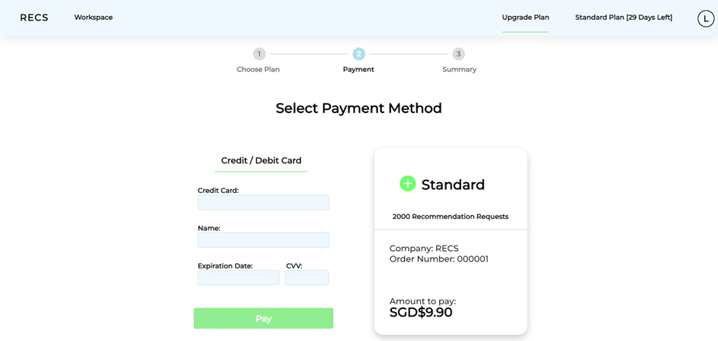

This will be the payment success page:

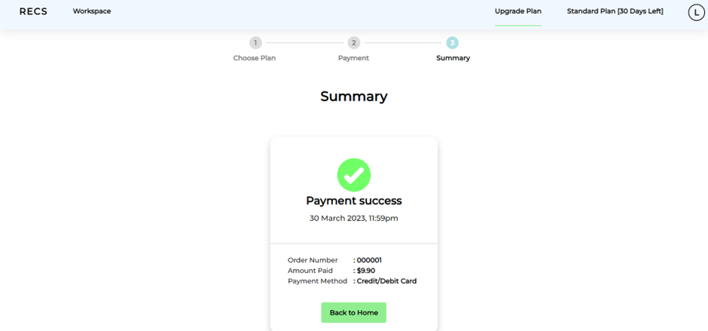

##### Organization:

Select either Standard ($14.90/month) or Pro plan ($49.90/month) for upgrade of plans.

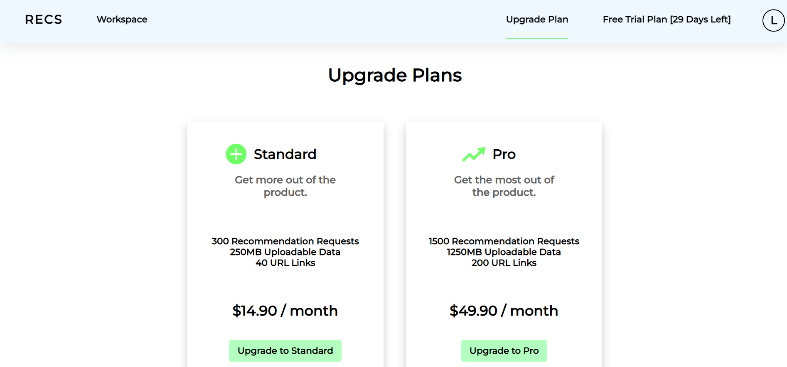

Upon selecting either of the options:

You have to key in your credit card details accordingly and click Pay:

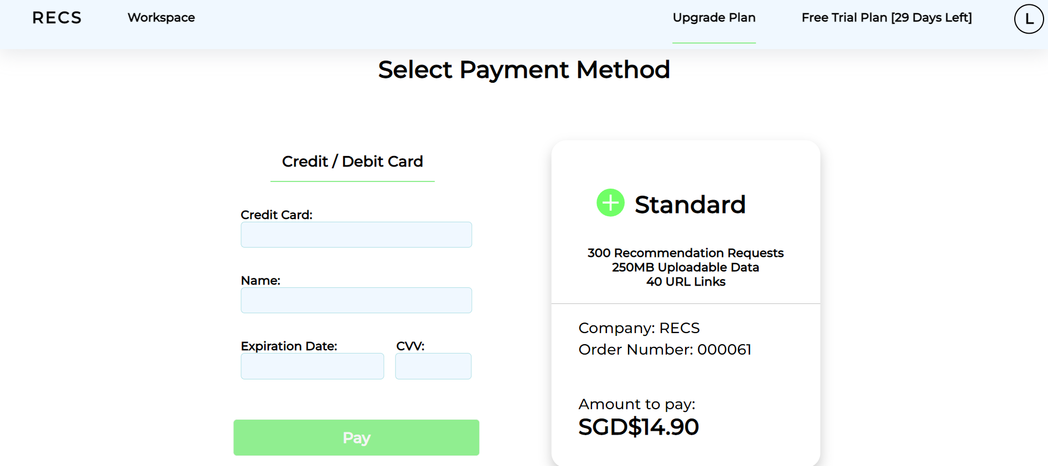

This will be the payment success page:

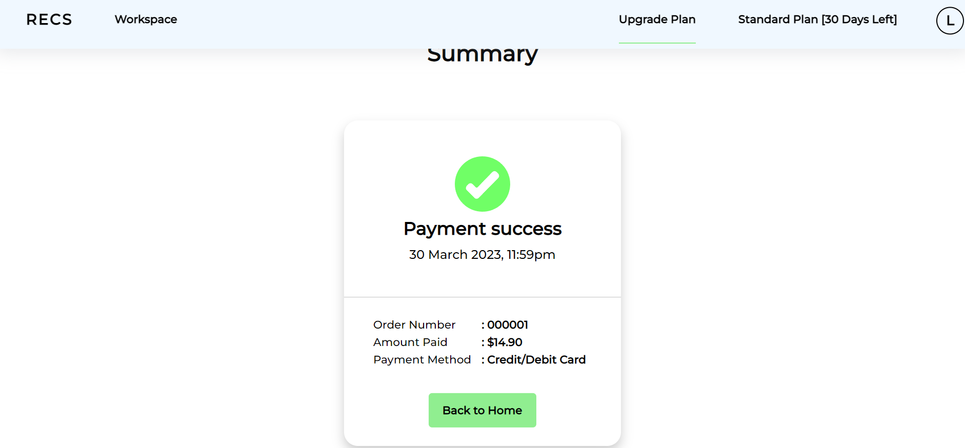

#### Quota and billing page:

##### Individual:

Quota:

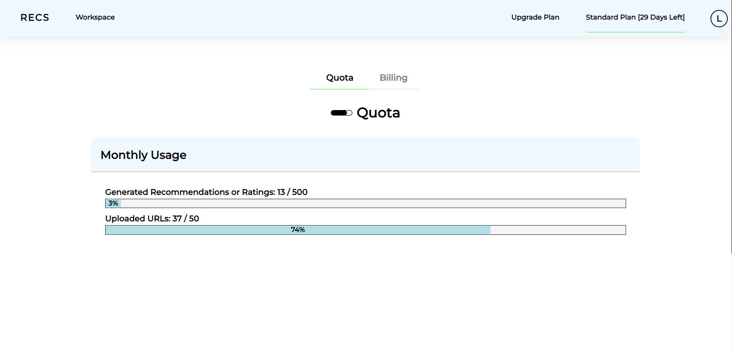

Billing tab:

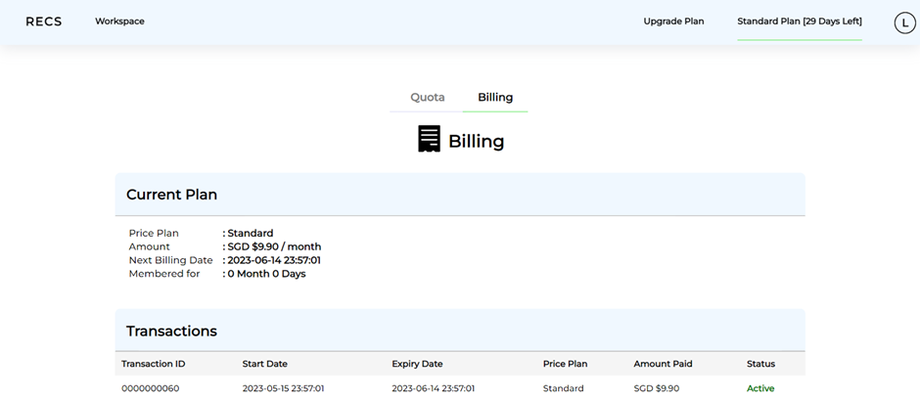

##### Organization:

Quota tab:

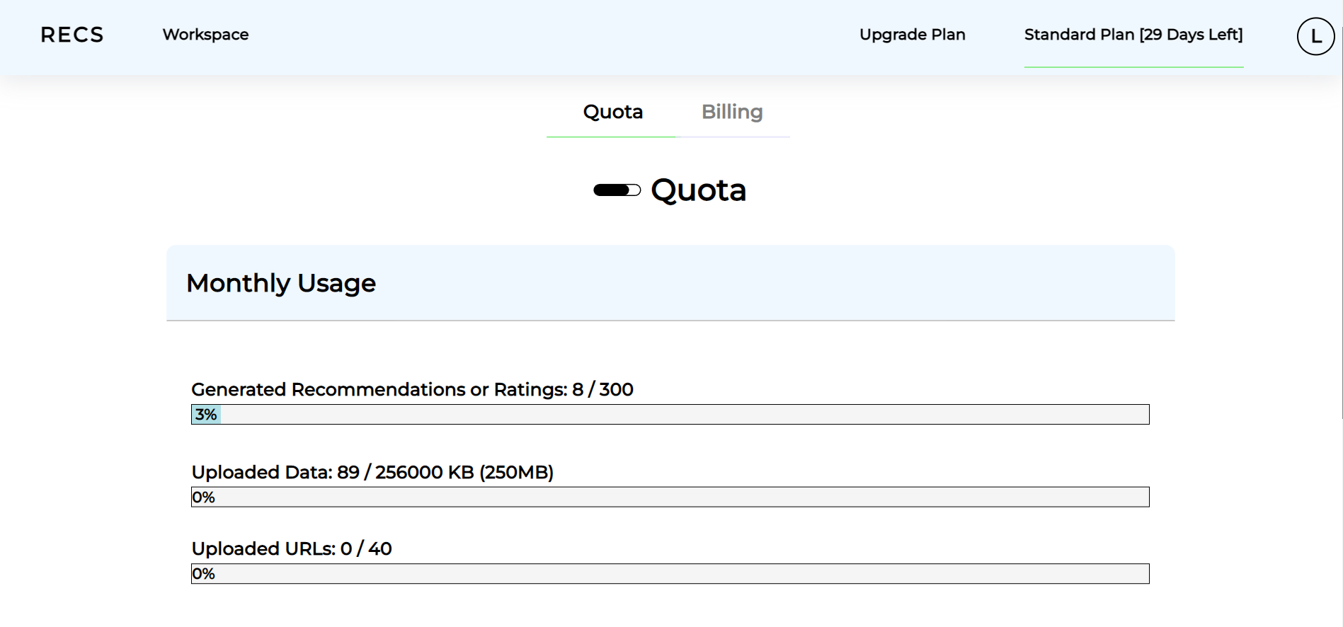

Billing tab:

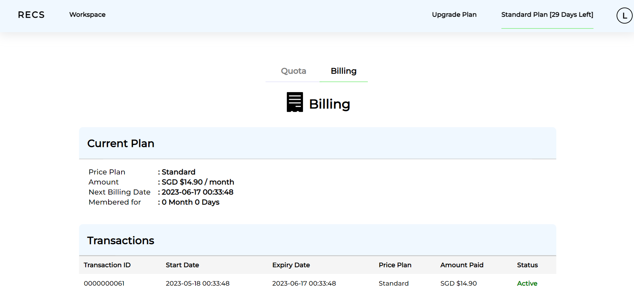

### Account settings:

Hover over the top right icon to show the dropdown list:

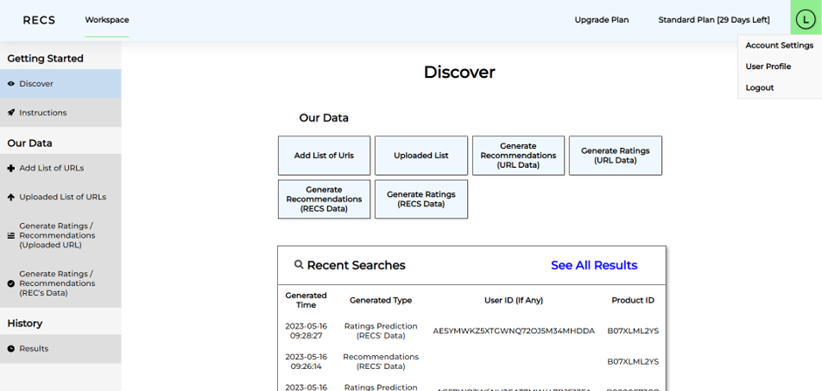

Select Account Settings:

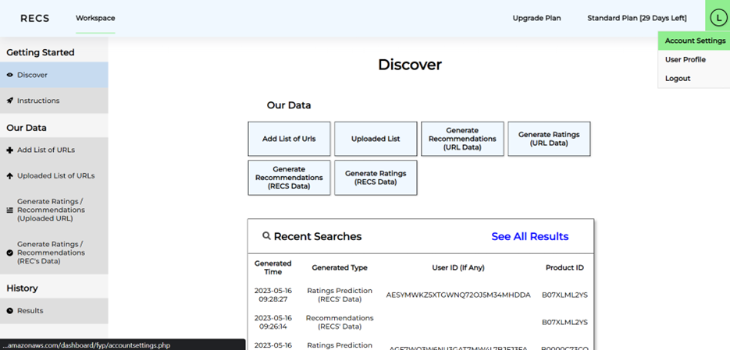

You are able to change your Name, or Password by clicking the edit button:

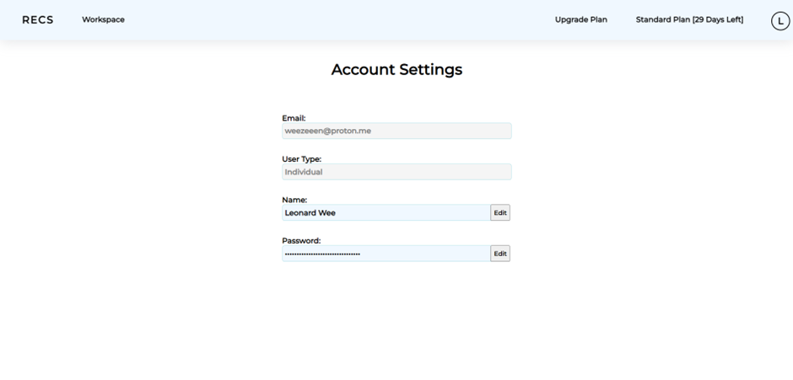

By clicking the Edit button beside the Name, you can type your new name and click confirm or cancel to go back to the previous page.

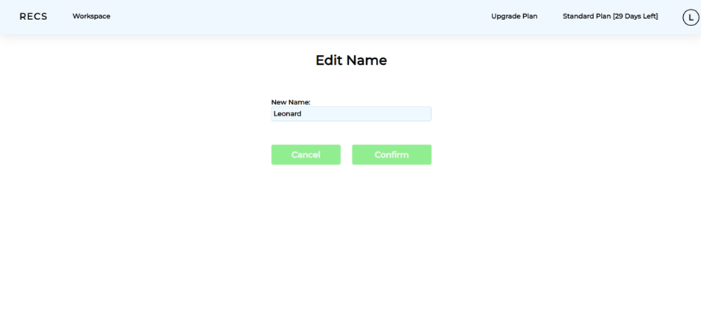

After clicking Confirm button, your name will be changed to the new name, it will prompt User Information successfully updated:

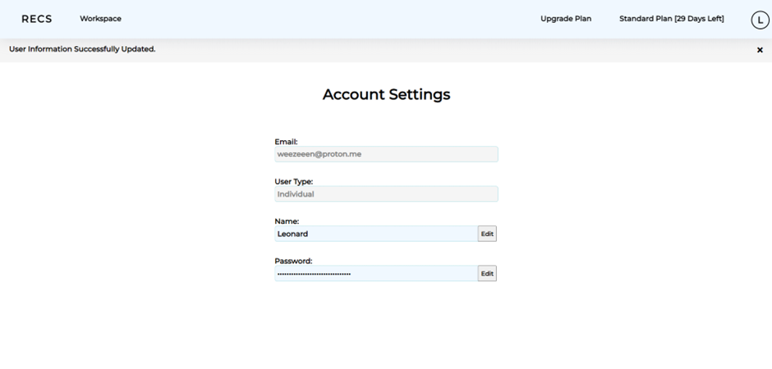

By clicking the Edit button beside the Password, you can type your current password, new password and Confirm New Password. Click confirm or cancel to go back to the previous page.

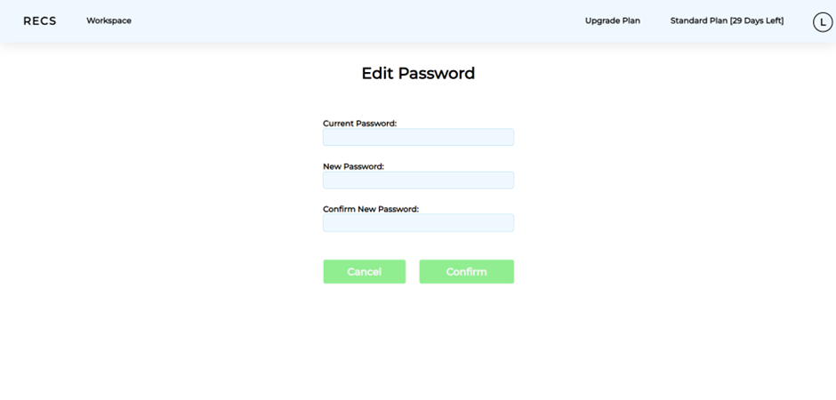

User Information Successfully Updated:



### User Profile:

Hover over the top right icon to show the dropdown list and select User Profile:

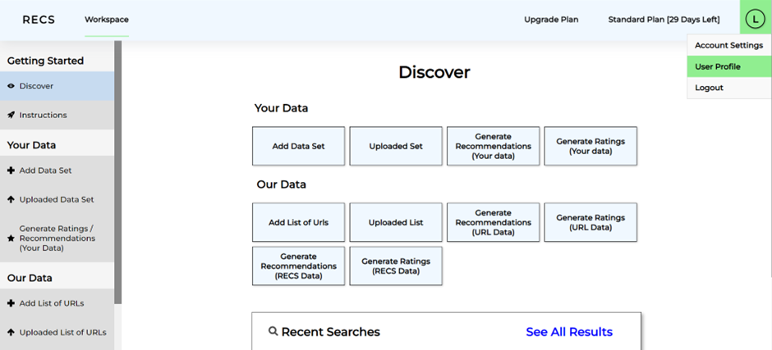

User is able to edit their Types of Products sold or Interests by clicking Edit:

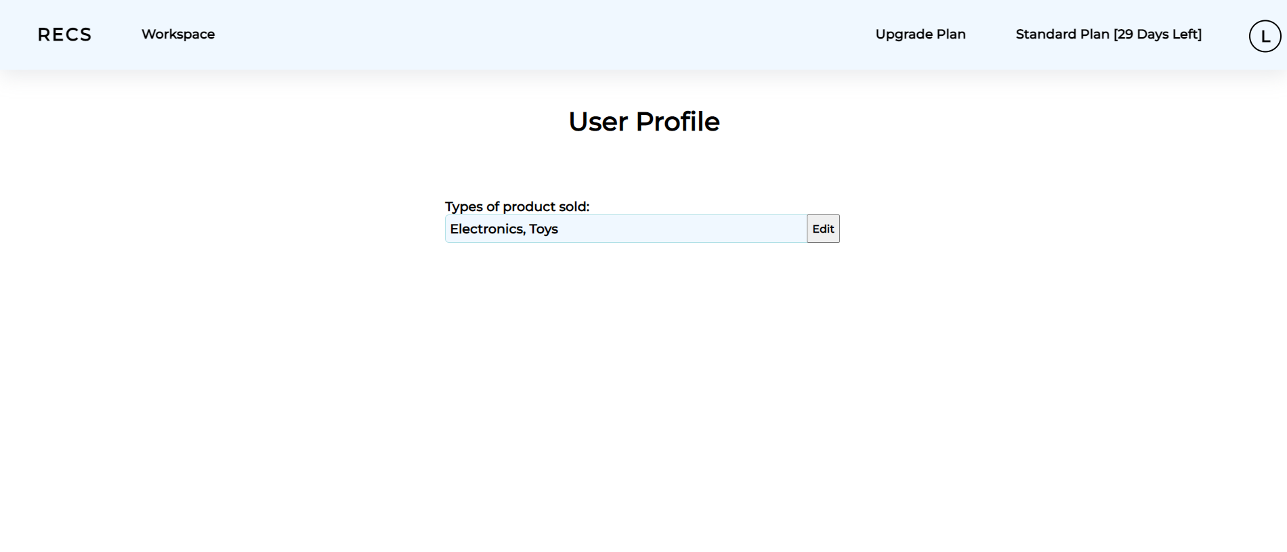

Users can select up to 5 categories and click confirm after they are done:

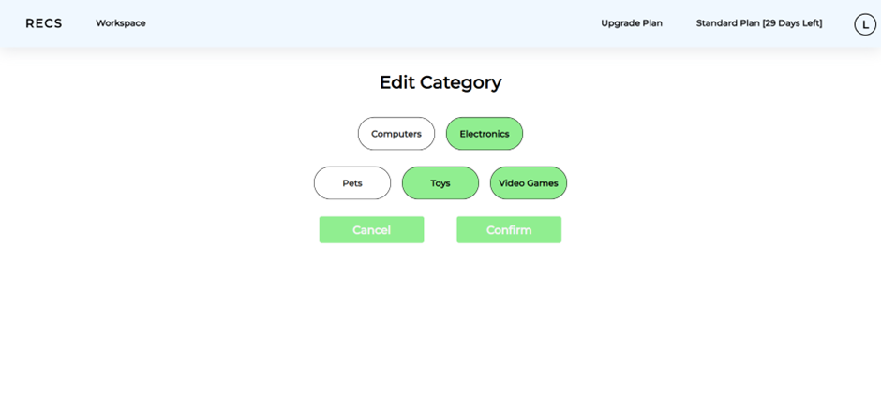

Categories successfully updated:

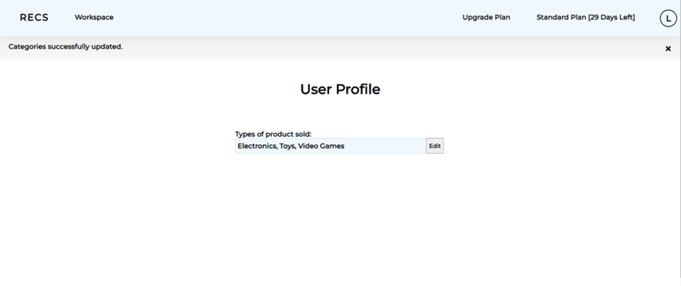

### Log Out:

Hover over the top right icon to show the dropdown list:



Select Logout button to log out:

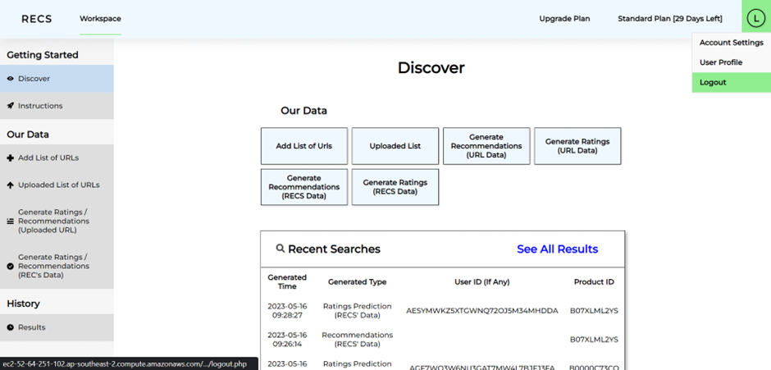

Head back to the RECs login page after logout:

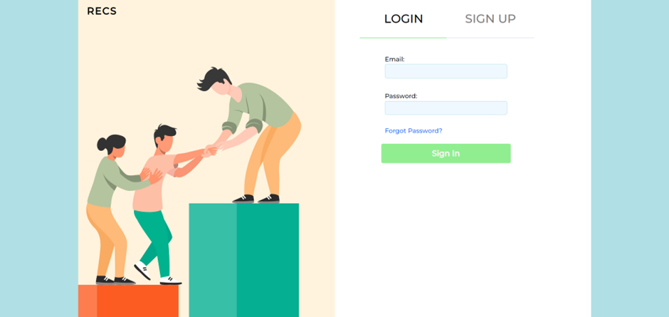

### Admin User:

#### Search Accounts:

Able to search and filter accounts based on their User Type:

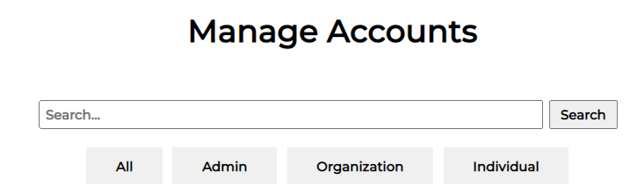

#### Manage accounts:

Able to manage user accounts:

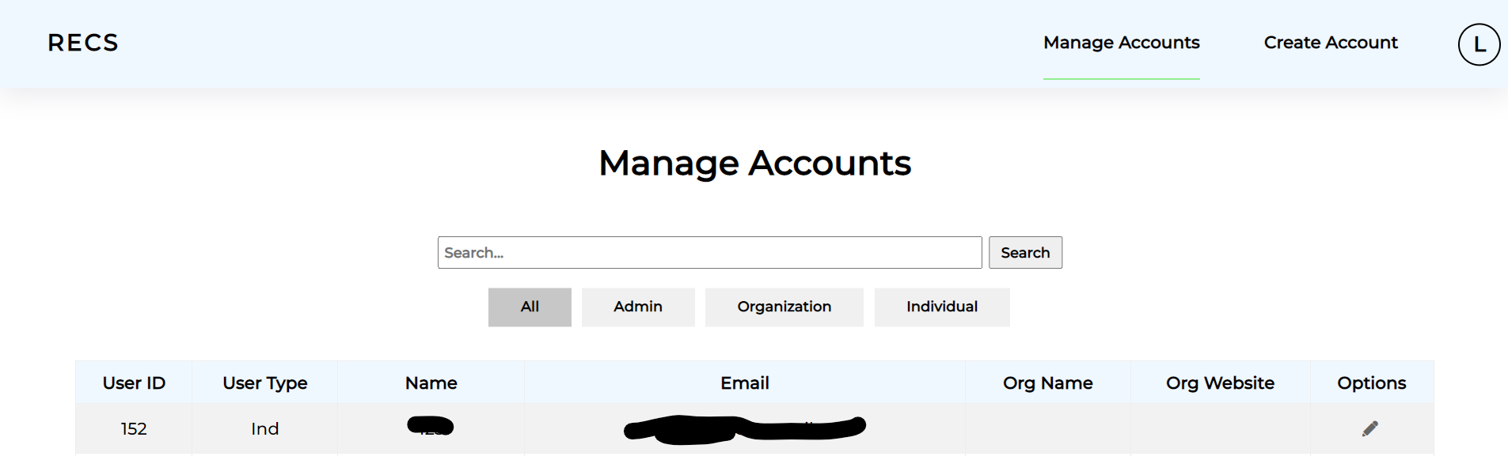

There are 3 options to select for each user, Edit, Manage and Delete:

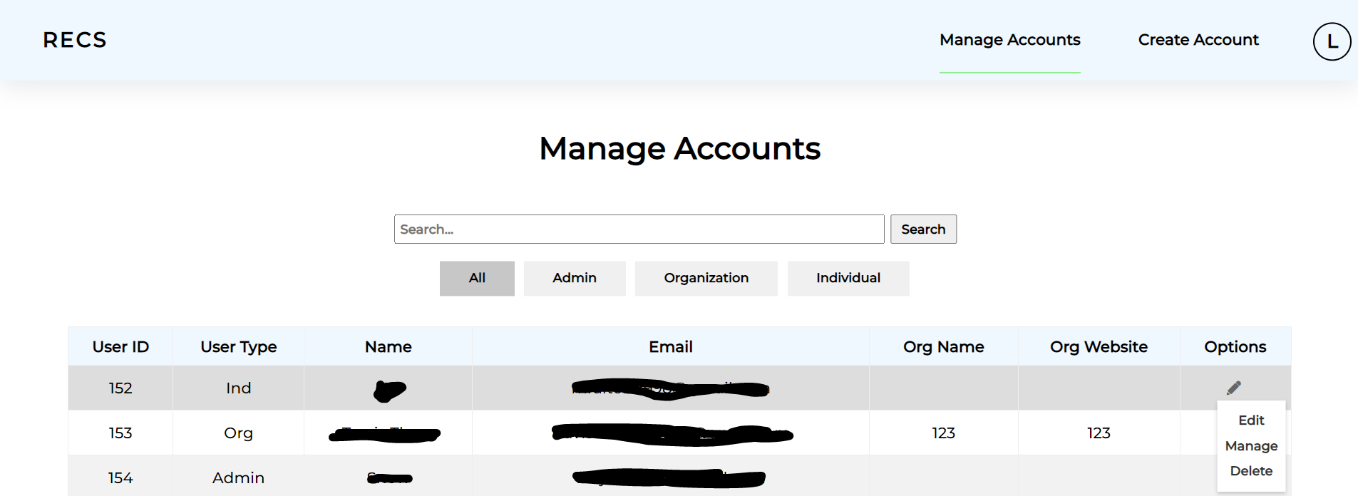

### 

##### Edit:

Able to edit their email, password, name, User Type and categories:

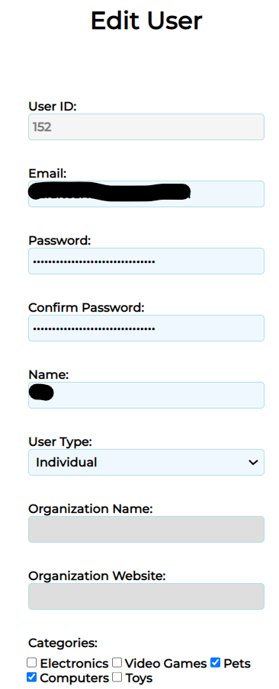

Able to Update or cancel the edit request:

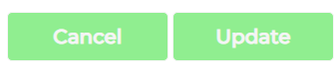

##### Manage:

Able to change the plans that the Individual or Organization is on, and account status.

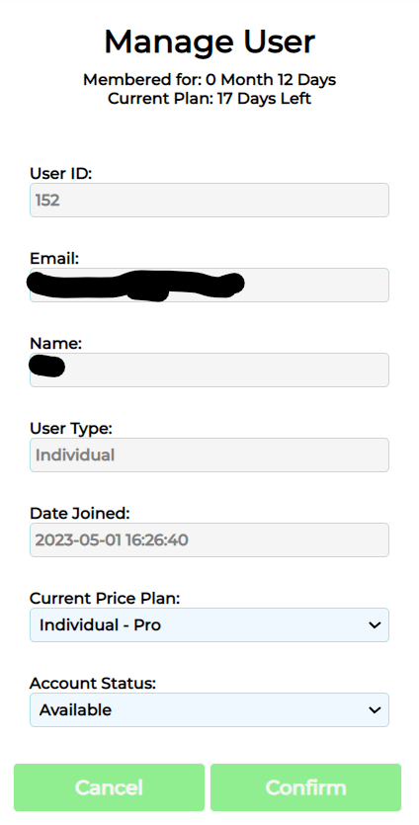

Able to Confirm the change or cancel the manage request.

##### Delete:

Able to delete the user by clicking Delete

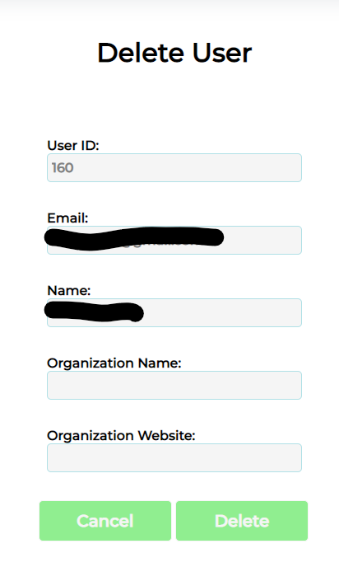

#### Create accounts:

##### Organization:

Fill in the required information like email, password, confirm password, name, organization name, organization website and their categories:

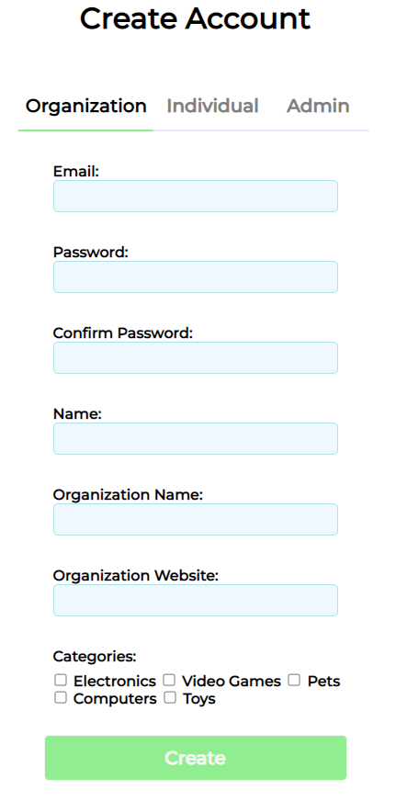

Click create to create an account.

##### Individual:

Fill in the required information like email, password, confirm password, name and his/her categories:

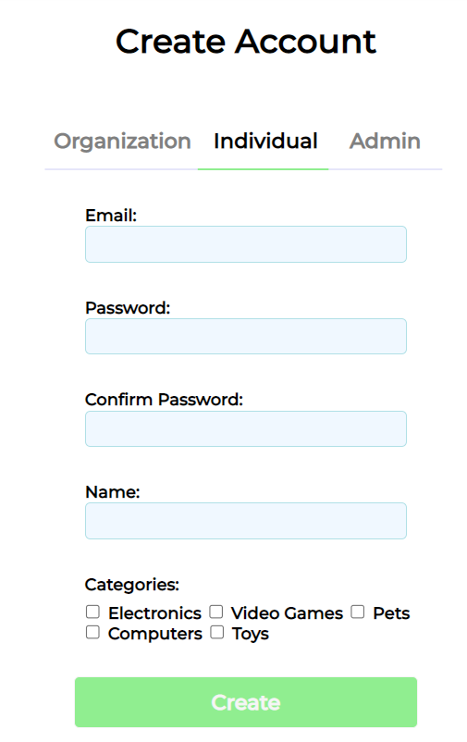

Click create to create an account.

##### User Admin:

Fill in the required information like email, password, confirm password, name and his/her categories:

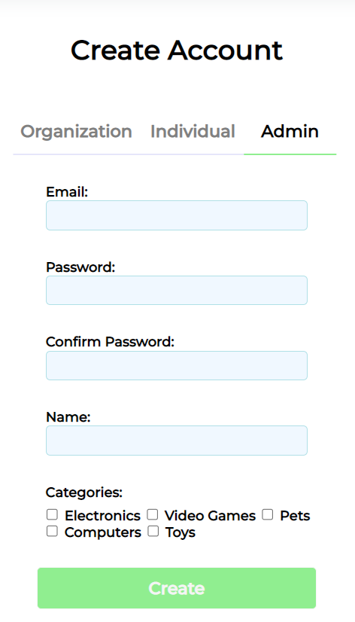

Click create to create an account.